Mechanism-Partitioned Optimization via Gate-Constrained AI Agent Search: De Novo NDM-1 Minibinder Design

ClearVoice AI Research Team
ClearVoice AI Research Portal
August 2026

Author Note
This manuscript synthesizes the complete three-month computational drug-discovery project report, methodology, quality-assurance record, Arbor search archive, and curated knowledge library published on the ClearVoice AI research portal (https://research.clearvoiceai.com). Correspondence concerning this report may be directed to the ClearVoice AI Research Team.

Abstract
Metallo-β-lactamases such as New Delhi metallo-β-lactamase-1 (NDM-1) hydrolyze carbapenem antibiotics and confer transferable, difficult-to-treat resistance in Gram-negative bacteria, yet the enzyme's shallow, di-zinc, conformationally mobile active site has resisted conventional small-molecule inhibitor design. This report synthesizes a three-month applied research program that progressed from an initial small-molecule proposal targeting LRRK2, through a generative-protein diagnostic concept for alpha-synuclein, to an implemented computational campaign that used generative protein design to propose compact "minibinder" proteins against NDM-1 under three explicit, falsifiable inhibition hypotheses: direct active-site metal engagement, allosteric loop-region control, and zinc-ion sequestration. The research gap addressed was not a lack of generative modeling capability but a lack of mechanism-aware, quality-controlled scientific discipline surrounding such models: an initial broadly autonomous agentic workflow failed when software task completion was mistaken for biological validity. The revised methodology therefore separated candidate generation (RFdiffusion3, LigandMPNN) from independent structural challenge (AlphaFold 3), encoded each hypothesis as a mechanism-specific multiplicative scoring function with non-negotiable structural and mechanism gates, subjected that evaluator to positive, negative, and boundary quality-assurance fixtures before use, and then restricted an autonomous hypothesis-tree search agent (Arbor, built on a GPT-5.5 coordinator-executor architecture) to edit only a bounded generation payload while the evaluator, target structure, and scientific rules remained protected. Three bounded Arbor searches, comprising 54 recorded hypothesis nodes and 23 scored evaluations, moved all three strategies from a gate-failing baseline to a gate-passing computational objective. The final leads were a 58-residue metal-engaging clamp (raw score 96.981/100; one supported zinc donor at 2.509 Å), a 76-residue allosteric loop clamp (raw score 92.296/100; AlphaFold 3 ipTM 0.87 with no direct binder–zinc contact), and a 63-residue sequestration candidate whose encounter geometry passed its gate despite an incomplete bidentate zinc-capture term (qCapture = 0.473). These results constitute three reproducible, mechanism-distinct structural hypotheses and a fully traceable evidence archive; they do not constitute evidence of physical binding, enzymatic inhibition, antibiotic resensitization, or periplasmic delivery, none of which were tested. The principal contribution is therefore methodological as much as candidate-specific: a demonstration that autonomous generative and agentic search systems can be made scientifically accountable by binding them to a versioned, quality-assured evaluator contract, and a staged experimental roadmap — independent computational replication, biochemical validation, delivery testing, and peptidomimetic miniaturization — for converting these computational leads into a tested β-lactam adjuvant candidate.
Keywords: antimicrobial resistance, NDM-1, metallo-β-lactamase, protein minibinder design, generative protein design, RFdiffusion3, LigandMPNN, AlphaFold 3, mechanism-aware scoring, autonomous research agents, hypothesis-tree search, Arbor, computational drug discovery, mechanism-partitioned optimization, gate-constrained AI agent search

Mechanism-Partitioned Optimization via Gate-Constrained AI Agent Search: De Novo NDM-1 Minibinder Design
Introduction
Antibiotic Resistance and the Metallo-β-Lactamase Problem
Antimicrobial resistance is a determinant of global mortality on par with major infectious diseases, and carbapenem-resistant Gram-negative pathogens are among the most clinically urgent forms of that resistance because carbapenems are frequently the last broadly effective β-lactam class available for severe infections. New Delhi metallo-β-lactamase-1 (NDM-1) is a principal driver of this problem. NDM-1 is a class B1 metallo-β-lactamase enzyme, not a bacterium and not identical to the blaNDM-1 gene that encodes it; the enzyme, its gene, the mobile plasmids that frequently carry that gene, and the bacterial hosts that express it are related but analytically distinct objects, and conflating them has historically confused both public description and technical modeling of the resistance problem. NDM-1 was first characterized in a carbapenem-resistant Klebsiella pneumoniae isolate (Yong et al., 2009), and blaNDM-1 was subsequently found on diverse, frequently transmissible plasmids across diverse Gram-negative hosts (Kumarasamy et al., 2010; Poirel et al., 2011), a dissemination route experimentally confirmed by conjugative mating studies (Potron et al., 2011).
Mechanistically, NDM-1 resides in the bacterial periplasm, anchored to the inner leaflet of the outer membrane as a lipidated lipoprotein with its catalytic domain exposed to periplasmic solvent (González et al., 2016; Prunotto et al., 2020). Its active site coordinates two chemically distinct zinc ions — Zn1, ligated by His120, His122, and His189, and Zn2, ligated by Asp124, Cys208, and His250 (Zhang & Hao, 2011) — which jointly organize a nucleophilic water or hydroxide that opens the β-lactam ring of susceptible antibiotics, including many penicillins, cephalosporins, and carbapenems (Feng et al., 2017). The active-site groove is bordered by the flexible L3 and L10 loop regions, whose conformational mobility helps explain the enzyme's broad substrate range and complicates any modeling assumption that treats the pocket as rigid (Mulligan et al., 2021). These same features — a shallow, solvent-exposed, adaptable, metal-dependent catalytic surface on a membrane-tethered target — make NDM-1 an unusually demanding design problem relative to the deep, rigid, druggable pockets that motivate most conventional structure-based drug design.
Current Drug-Discovery Challenges for Metallo-β-Lactamases
Serine-β-lactamase inhibitors such as avibactam and vaborbactam have reached clinical use in combination with partner β-lactams, but their catalytic chemistry is not transferable to metallo-β-lactamases, whose mechanism depends on active-site zinc rather than an acyl-enzyme serine intermediate; approval of a serine-β-lactamase inhibitor combination therefore provides no direct evidence of activity against NDM-1, and NDM coverage must be established independently for any candidate. Prior experimental work does establish that the NDM-1 active site is chemically addressable: captopril and computationally designed peptide macrocycles occupy the catalytic cleft and engage the metal center (King et al., 2012; Mulligan et al., 2021), and the natural product aspergillomarasmine A inhibits NDM-1 by selectively sequestering catalytic zinc after its dissociation from the enzyme, restoring meropenem susceptibility in combination therapy (King et al., 2014; Sychantha et al., 2021). These precedents motivate metal engagement and zinc sequestration as chemically plausible inhibition routes, but they do not resolve the central design difficulty: removing zinc from a computational model to simplify docking or generation changes the biological system being modeled, while forcing zinc into an assumed coordination geometry risks producing a plausible-looking but chemically unsupported pose. A third, less chemically obvious route — allosteric modulation via the L3/L10 loop network — has more equivocal mechanistic support: a 2019 peer-reviewed study attributed activity of the antimicrobial peptide thanatin partly to direct zinc displacement (Ma et al., 2019), while a 2026 preprint instead reports zinc-preserving loop rigidification as the operative mechanism (Rivière et al., 2026); the present work treats the latter as a testable hypothesis rather than settled fact. Finally, even a fully validated inhibitor of purified NDM-1 solves only part of the therapeutic problem, because the enzyme's native, membrane-anchored, periplasmic localization means that binding evidence generated in solution does not establish that a candidate — particularly a folded protein of several kilodaltons — can cross the Gram-negative outer membrane to reach its target in an intact cell (Housden et al., 2010).
AI-Driven Drug Discovery and the Case for Mechanism-Aware Design
Generative structural biology has advanced rapidly enough to make de novo protein binder design a practical laboratory tool rather than a purely theoretical exercise. Diffusion-based backbone generators can propose target-conditioned protein folds, sequence-design networks can recover amino-acid sequences compatible with a target backbone and any bound ligands or metals, and independent structure predictors can assess whether a proposed complex is likely to fold and bind as intended. The risk in applying this stack to a project such as NDM-1 inhibitor discovery is not technical infeasibility but interpretive overreach: a generative model, a docking score, or an autonomous agent can produce an artifact that is procedurally complete — a candidate was generated, a job finished successfully, a number was printed — without that artifact being scientifically meaningful. The project documented in this report experienced this failure mode directly. An early, broadly autonomous agentic workflow was found to treat software task completion as equivalent to biological validity, producing candidates that satisfied a generation pipeline without satisfying the target's actual chemistry (for example, without correctly preserving the enzyme's two catalytic zinc ions or the true identity of a numbered residue). Correcting this failure, rather than simply generating more candidates, became the project's central methodological turn: replacing an unconstrained agent with a mechanism-aware, quality-controlled research contract in which every claim of "improvement" is defined, tested, and gated before an autonomous search agent is permitted to act on it. This orientation places the present work within a broader movement toward evaluator-centric and agentic scientific automation, most directly illustrated by the Arbor framework for hypothesis-tree-refined autonomous optimization (Jin et al., 2026), which supplied the search architecture adopted here, and by contemporaneous discussion of the proper division of labor between autonomous agents and human researchers in biological science (Adaptyv Bio, as cited in the project's knowledge library).
Why Minibinders
The project's implemented direction targets NDM-1 with compact designed proteins — "minibinders" in the 58–76 residue range — rather than small molecules, peptides alone, or antibodies. This choice follows directly from the platform's demonstrated generative capability: RFdiffusion3 and LigandMPNN are protein- and biomolecule-design models, not general small-molecule generators, and an earlier attempt within this same project to redirect them toward small-molecule generation for an unrelated central-nervous-system target failed to adequately address that target's separate blood–brain-barrier delivery requirement, reinforcing that generation modality must match model capability rather than target convenience. Minibinders also offer a favorable middle ground for a first computational campaign against a difficult target: they are large enough to form an extended, multi-residue interface capable of engaging a shallow, adaptable groove — a mode of engagement more consistent with the successful macrocyclic peptide precedent (Mulligan et al., 2021) than with a small, compact ligand — while remaining substantially smaller and more tractable to generate, sequence-design, and structurally evaluate than a full antibody or engineered enzyme scaffold. Minibinders are, at the same time, explicitly understood within this project as probes and pharmacophore sources rather than presumptive final therapeutics: their size (approximately 6.4–8.4 kDa for the three final leads) places them well outside passive diffusion through general outer-membrane porins, so a validated minibinder mechanism is treated as a starting geometry for later peptidomimetic or small-molecule miniaturization rather than as a finished drug candidate.
Literature Review
The literature informing this project falls into four bodies of work. First, the structural and mechanistic biology of NDM-1 and related metallo-β-lactamases establishes the di-zinc catalytic mechanism, the adaptable L3/L10 substrate groove, and the enzyme's membrane-anchored periplasmic localization (Yong et al., 2009; Zhang & Hao, 2011; Feng et al., 2017; González et al., 2016; Prunotto et al., 2020). Second, a smaller body of inhibitor-discovery literature demonstrates that the active site is chemically addressable through at least two distinct routes — direct metal-proximal engagement, as with captopril and designed macrocyclic peptides (King et al., 2012; Mulligan et al., 2021), and post-dissociation zinc sequestration, as with aspergillomarasmine A (King et al., 2014; Sychantha et al., 2021) — while leaving a third, allosteric route mechanistically contested between direct zinc displacement and zinc-preserving loop rigidification (Ma et al., 2019; Rivière et al., 2026). Third, the generative structural biology stack adopted by the platform draws on independently published model architectures for protein backbone generation, ligand-aware sequence design, and biomolecular complex structure prediction, most directly AlphaFold 3 for independent complex prediction (Abramson et al., 2024), alongside a wider registry of candidate adapters for a proposed chemistry extension of the platform — including docking (Corso et al., 2023), orthogonal complex prediction (Passaro et al., 2025; Chai Discovery Team et al., 2024), pocket-conditioned small-molecule generation (Feng et al., 2024), three-dimensional molecular representation learning (Zhou et al., 2023), machine-learned interatomic potentials (Batatia et al., 2022; Anstine et al., 2025), and retrosynthetic planning (Genheden et al., 2020; Tu et al., 2025). Fourth, the search methodology itself is grounded in the Arbor hypothesis-tree-refinement framework for autonomous optimization, which formalizes a research task as an initial artifact, a fixed objective, a development evaluator, and — in the framework's general form — a held-out evaluator, coordinated through a persistent hypothesis tree rather than an unstructured agent conversation (Jin et al., 2026).
Research Gap
None of these literatures, individually, addresses the specific problem this project confronted: how to let a generative and agentic AI system search for NDM-1 inhibitor candidates without allowing the search process to silently substitute software completion for scientific correctness. The structural-biology literature establishes what a correct answer would need to look like but does not specify a computational search procedure. The generative-modeling literature establishes that target-conditioned protein generation and independent structure prediction are technically available but does not, by itself, guarantee that a generated candidate respects a target's essential chemistry (for example, its metal centers) or that a search agent's self-reported improvement reflects a genuine gain rather than an exploited evaluator weakness. The autonomous-agent literature, including the Arbor framework itself, supplies a general architecture for bounded, evidence-preserving search but does not supply the target-specific scientific content — the mechanism hypotheses, hard gates, and quality-assurance fixtures — needed to make that architecture trustworthy for a particular biological target. The gap this project addresses is therefore integrative and methodological: constructing, testing, and applying a mechanism-aware evaluator contract that can safely bound an otherwise capable but unconstrained generative and agentic AI pipeline for a genuinely difficult, metal-dependent, membrane-associated drug target.
Research Question and Hypothesis
The research question motivating the implemented campaign was: can generative protein models propose compact minibinder proteins that form structurally plausible, mechanism-relevant complexes with NDM-1 under explicitly defined and independently testable inhibition mechanisms? The corresponding primary computational hypothesis was that compact designed proteins can form structurally plausible, mechanism-relevant complexes with NDM-1 when three conditions hold: the di-zinc center is represented explicitly rather than removed or assumed, candidate generation is separated from candidate evaluation by an independent structural predictor, and each proposed inhibition mechanism is given its own falsifiable, mechanism-specific test rather than a single generic binding score. Success, under this hypothesis, was defined deliberately narrowly, as mechanism-consistent structural evidence surviving explicit hard gates — not as a high raw confidence value in isolation, and not as any claim about binding affinity, catalytic inhibition, or therapeutic efficacy, none of which this computational hypothesis attempts to establish.
Project Contributions
This report makes four contributions. First, it documents a complete, reusable proposal-to-evidence research platform — proposal, scoring design, quality-assurance testing, a versioned Evaluator Pack, bounded Arbor search, and a traceable evidence archive — that is proposal-agnostic in its infrastructure while remaining strictly target- and mechanism-specific in its scientific content. Second, it reports a mechanism-aware, multiplicative evaluator architecture for NDM-1 minibinder design that separates a common structural-validity gate from three independent, falsifiable mechanism-specific gates and scoring terms, and it reports the quality-assurance program — including a known-system rehearsal on an unrelated insulin-receptor complex and three mechanism-challenge fixtures with predetermined expected outcomes — used to verify that this evaluator rewards genuine mechanistic evidence rather than superficial model confidence. Third, it reports the outcome of three bounded, evidence-preserving Arbor searches against this tested evaluator, yielding three reproducible, mechanism-distinct computational leads together with their complete negative-result and failure-mode record. Fourth, it translates the resulting evidence, together with the explicit boundary between computational prioritization and experimental validation, into a staged, falsification-oriented experimental roadmap — spanning independent computational replication, biochemical and biophysical testing, delivery-route assessment, and peptidomimetic miniaturization — intended to convert the strongest leads into an eventual β-lactam adjuvant candidate without overstating what the computational campaign alone has shown.
Method
Overall System Architecture
The platform separates two layers that are easy to conflate in agentic AI research: a reusable proposal-agnostic infrastructure, and target-specific scientific content that changes with every project. The infrastructure layer defines six invariant responsibilities that apply regardless of the scientific question being asked. A scientific proposal states the question, objective, hypothesis, starting data, constraints, intended evidence, and known limitations. A scoring design translates "better" into required measurements, hard rejection rules, weighted evidence terms, penalties, and a single comparable objective. Quality-assurance (QA) tests verify inputs, measurements, gates, edge cases, expected rankings, and failure handling before any search begins. A versioned Evaluator Pack packages the tested proposal, evaluator, QA evidence, data contracts, allowed computational capabilities, compute budget, and provenance rules into a single sealed contract. Arbor experiments then read that complete pack, branch on explicit hypotheses, run only permitted experiments, evaluate results with the protected evaluator, and checkpoint progress. Finally, traceable evidence connects every reported conclusion back to its originating hypothesis, evaluator version, inputs, artifacts, and decision history. The content layer — the NDM-1 target structure, its three mechanism-specific evaluators, and its QA fixtures — is specific to this campaign and is precisely what the infrastructure layer is designed to protect from unauthorized modification during search (Figure 1).
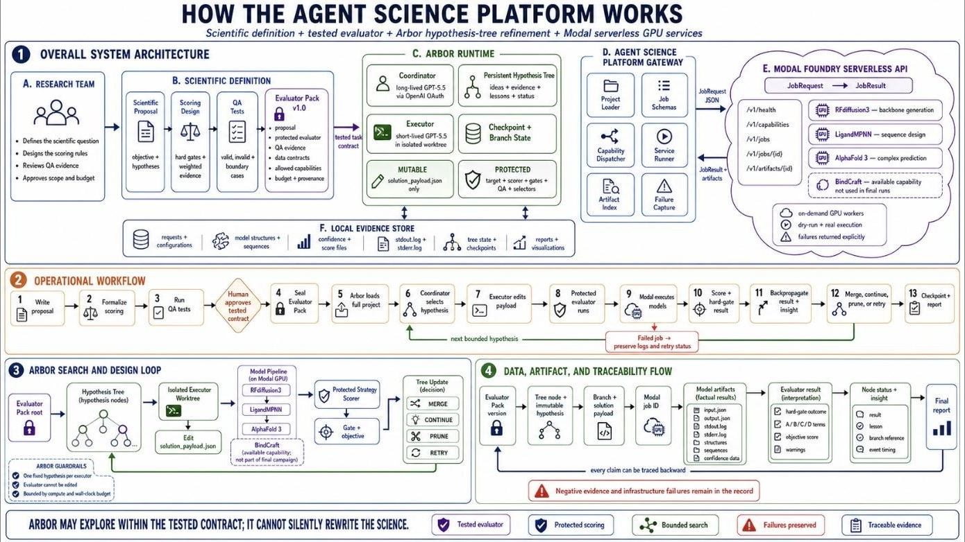
Figure 1
Reusable Agent Science platform architecture, showing the research team, scientific definition and tested Evaluator Pack, Arbor runtime, Agent Science gateway, Modal serverless model API, local evidence store, operational workflow, and traceability flow that together compose the proposal-agnostic infrastructure layer.
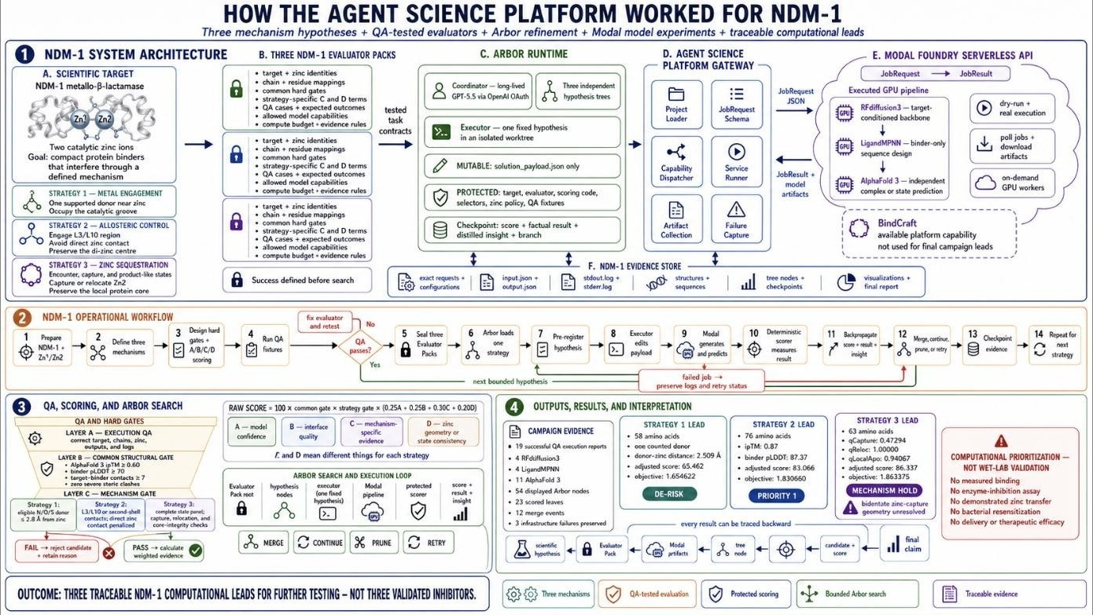
Figure 2
Instantiation of the platform architecture for the NDM-1 campaign, showing the three mechanism-specific Evaluator Packs, the Arbor coordinator–executor runtime, the Modal model-service gateway, the local evidence store, and the boundary between computational prioritization and laboratory validation.
Drug-Discovery Workflow and AI Pipeline
The production pipeline exposes GPU-intensive structural biology models through a common, on-demand serverless job API (Modal), and it retains — for every job — the request, output, execution logs, generated structures, confidence data, and local QA artifacts, rather than relying on a narrative summary of what occurred. The pipeline proceeds through six stages, illustrated for the NDM-1 case in Figure 3. First, the target is prepared, preserving native chain identity, residue numbering, and both zinc entities exactly as they occur in the reference structure. Second, RFdiffusion3 proposes target-conditioned minibinder backbone structures, conditioned on strategy-specific hotspot residues and, where relevant, explicit chemical context around the zinc center. Third, LigandMPNN redesigns only the binder chain's sequence while holding the NDM-1 target and any ligand or metal context fixed, so that sequence design cannot silently alter the target being challenged. Fourth, AlphaFold 3 independently predicts the selected design's fold and its complex with NDM-1, supplying the confidence and geometric evidence on which the evaluator subsequently depends; this predictor is structurally and procedurally independent of the RFdiffusion3/LigandMPNN generation step, which is the project's primary safeguard against a generator being permitted to grade its own output. Fifth, mechanism-specific scoring code computes core structural quality, interface quality, mechanism engagement, and zinc-state realism from the downloaded AlphaFold 3 artifacts. Sixth, all structures, provenance metadata, metrics, failures, and decisions are inspected and retained in the local evidence store.
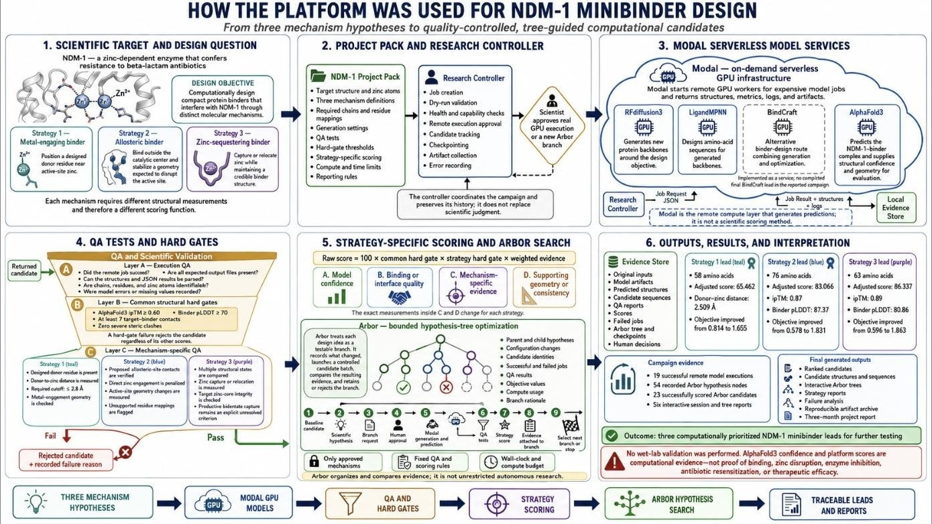
Figure 3
Implemented NDM-1 workflow, showing how three mechanism hypotheses were translated into Modal model jobs, QA-tested strategy-specific scores, Arbor search trees, and traceable computational leads.
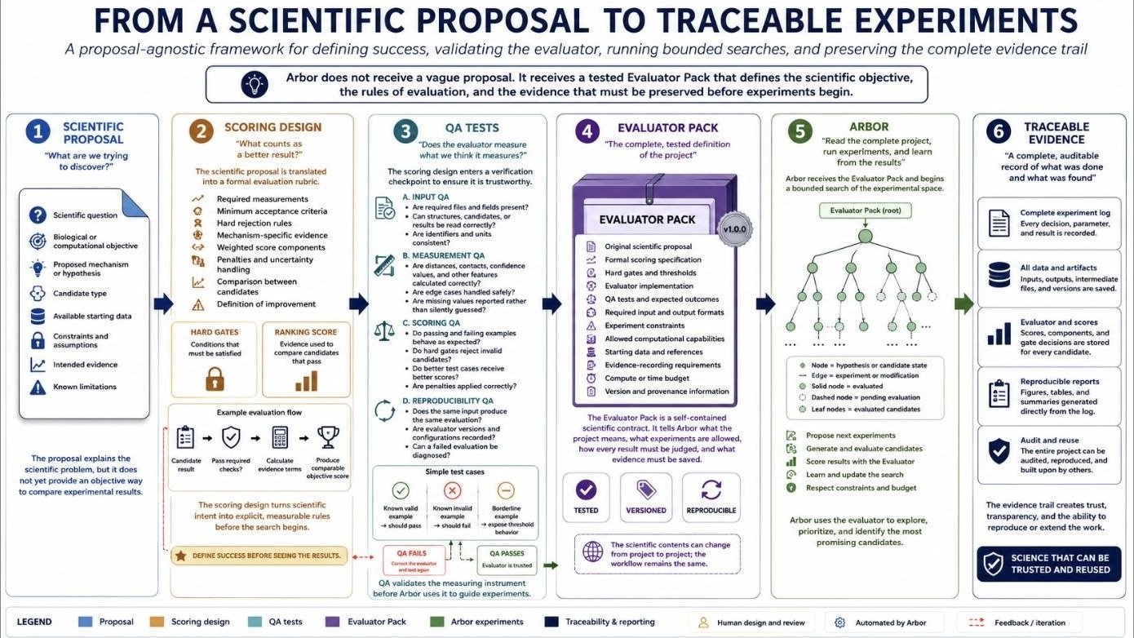
Figure 4
Six-stage, proposal-agnostic platform workflow: scientific proposal, scoring design, QA tests, Evaluator Pack, Arbor hypothesis tree, and traceable evidence.
Target Preparation and Protein Representation
NDM-1 was represented as a single 232-residue chain together with its two native catalytic zinc ions, using verified structural labels checked against amino-acid identity rather than residue number alone. The L3 loop was defined as residues A65–A73 (sequence LDMPGFGAV) and the L10 loop as residues A210–A230 (sequence IKDSKAKSLGNLGDADTEHYA); an earlier, incorrect A210–A228 boundary present in project notes was explicitly not reused once the corrected A210–A230 range was verified, and this correction was recorded in the target-preparation manifest supplied to the evaluator. Nominal second-shell residue labels that, upon inspection, mapped to an amino acid inconsistent with the intended identity (for example, an expected histidine position occupied by alanine in a given model) were excluded from scoring credit and flagged with an explicit warning rather than silently accepted, on the reasoning that a residue number alone is not sufficient evidence for a chemical claim if the modeled identity at that position does not match.
Feature Extraction and Measurement
Structural evidence was extracted directly from downloaded AlphaFold 3 outputs rather than accepted from generation-time metadata, so that scoring reflected an independently predicted structure rather than the generator's own claims. Extracted features included the AlphaFold 3 interface predicted template modeling score (ipTM) as a whole-complex confidence signal; per-residue predicted local distance difference test (pLDDT) scores summarized for the binder and interface; a fixed-distance contact definition between binder and target residues; buried surface area upon complex formation; a clash penalty for physically implausible atomic overlap; donor-atom identification (nitrogen, oxygen, or sulfur atoms capable of metal coordination under the campaign's chemistry rule) and their distances to each zinc ion; Zn–Zn separation and zinc-displacement measures relative to the native holo reference; and, for the metal-engagement strategy, a geometric substrate-access-envelope overlap measure ("qBlock") built from seven carbapenem-bound NDM-1 reference structures and aligned into each candidate's predicted frame on a 0.5 Å grid (Figure 5).
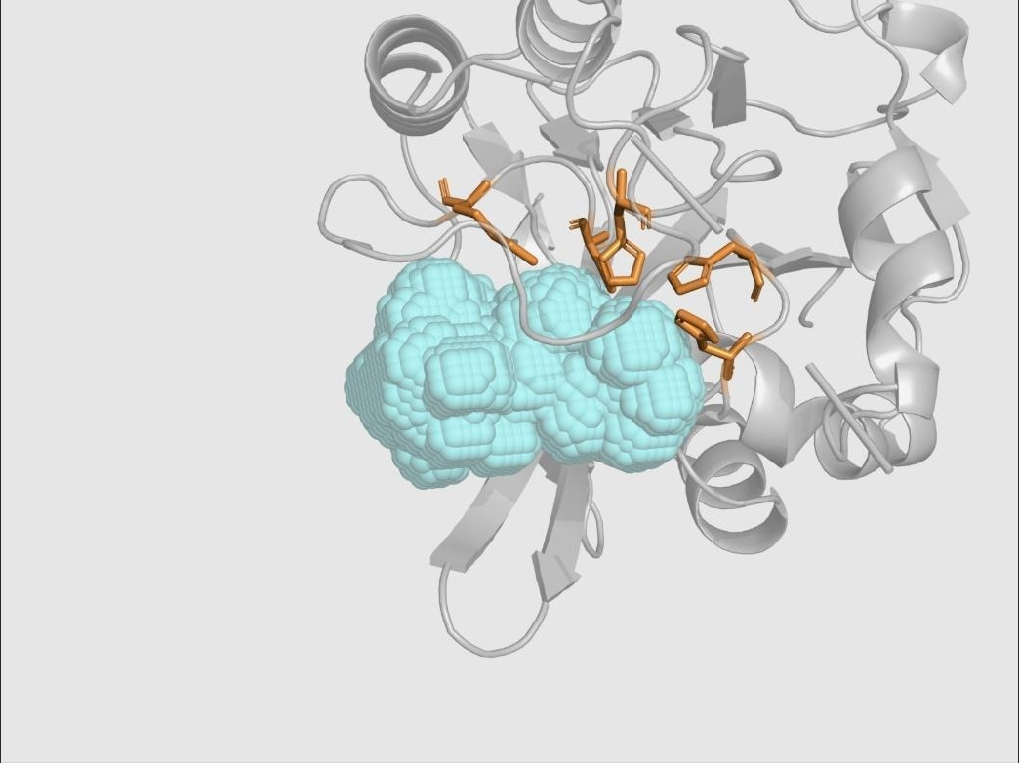
Figure 5
Reference substrate-access envelope (cyan) constructed from seven carbapenem-bound NDM-1 structures in native target coordinates, used as the geometric basis for the qBlock active-site-obstruction measurement.
Candidate Generation
Two complementary generation capabilities were implemented and QA-executed: RFdiffusion3 for target-, hotspot-, and chemical-context-conditioned backbone generation, and LigandMPNN for binder-only sequence design that preserves target and metal context. A third capability, BindCraft, was implemented as an alternative binder-generation route within the platform and workbench but had no completed, supplied QA execution or final lead in this campaign and is therefore reported as an available but unused capability rather than as an evaluated method (Table 1).
Table 1
Implemented Generation and Prediction Capabilities and Their Evidence Status
Capability | Role in the Implemented Platform | Evidence Status
RFdiffusion3 | Target-, hotspot-, and chemical-context-conditioned protein backbone generation | Executed in QA and final campaigns
LigandMPNN | Binder sequence design while preserving target and ligand/metal context | Executed in QA and final campaigns
AlphaFold 3 | Independent fold and target-complex prediction used by the evaluator | Executed in QA and final campaigns
BindCraft | Alternative binder-generation wrapper in the platform and workbench | Implemented; no completed QA execution or final lead

Mechanism-Aware Reasoning: Three Inhibition Hypotheses
Rather than scoring every candidate against one generic binding criterion, the platform encoded three biologically distinct, independently falsifiable inhibition hypotheses, each with its own campaign test and its own peer-reviewed or provisional precedent (Figure 6 in the Appendix summarizes the correspondence between biology and scoring). Strategy 1, direct metal engagement, hypothesizes that a binder can occupy the catalytic groove and position a chemically supported nitrogen, oxygen, or sulfur donor atom within 2.8 Å of Zn1 or Zn2 while avoiding indiscriminate over-chelation; its campaign test required a qualifying donor within that distance, explicit zinc retention, and a passed reference-geometry check, and its precedent is the captopril and designed-macrocycle literature (King et al., 2012; Mulligan et al., 2021). Strategy 2, allosteric loop-region control, hypothesizes that a binder can engage the L3/L10 boundary or nearby second-shell network while preserving a native-like di-zinc center and deliberately avoiding direct binder–zinc coordination; its campaign test required at least two qualifying loop or second-shell contacts, explicit zinc retention, and consistency with a native-like holo reference ensemble, and its provisional precedent is the 2026 zinc-preserving reinterpretation of thanatin's loop-rigidification mechanism (Rivière et al., 2026), used explicitly as a testable hypothesis rather than settled fact. Strategy 3, zinc sequestration, hypothesizes that a binder can capture Zn2, disrupt native coordination locally, and leave the NDM-1 protein core intact; its campaign test required a four-state panel — binder-alone fold, encounter complex, zinc-capture construct, and product-like construct — rather than a single attractive pose, and its precedent is the sequestration mechanism of aspergillomarasmine A (King et al., 2014; Sychantha et al., 2021), understood as an extrapolation from small-molecule to protein-mediated capture that the campaign explicitly treats as unvalidated until tested.
Scoring Design and Ranking Pipeline
Every candidate first passed, or failed, a common structural-validity gate requiring an AlphaFold 3 ipTM of at least 0.60, a binder pLDDT of at least 70, at least seven target-binder contacts under a fixed contact definition, and zero severe clashes under the campaign's clash test. A candidate that failed this common gate, or its strategy-specific mechanism gate, received a raw mechanism score of zero regardless of any otherwise favorable metric — the gates are strictly non-negotiable and cannot be offset by strong performance elsewhere. A candidate that passed both gates was then scored on four normalized, zero-to-one evidence terms, each independently interpretable: A, an AlphaFold 3 confidence term derived from ipTM (weight 0.25); B, an interface-quality term combining contact count, buried surface area, contact density, interface confidence, polar satisfaction, and clash penalties (weight 0.25); C, a strategy-specific mechanism-engagement term whose exact composition differs across the three strategies (weight 0.30, the largest single weight, reflecting that mechanism evidence is the project's primary scientific interest); and D, a strategy-specific zinc-realism term (weight 0.20). The resulting raw score is
Raw score = 100 × core gate × mechanism gate × (0.25A + 0.25B + 0.30C + 0.20D),
where the two gate terms are binary (1 if passed, 0 if failed) and therefore act multiplicatively rather than additively on the weighted evidence sum. A campaign-level binder-length adjustment converts the raw 0–100 score into a campaign-adjusted score, and the value passed to the Arbor search agent as its optimization objective is
Arbor objective = 1 + (campaign-adjusted score / 100),
so that any candidate failing a required gate necessarily produces an objective at or below 1.0, while any candidate passing both gates necessarily produces an objective above 1.0; crossing this 1.0 boundary, rather than the magnitude of any percentage change, is the scoring design's primary decision-relevant event. A worked numerical example, together with the complete quality-assurance verification of this scoring logic, is reported in the Experiments and Results section. Ranking additionally applied four supplementary rules: candidates were ranked only within their own mechanism strategy, never pooled across strategies as though the underlying scores were commensurable; a small carbapenem-priority bonus (at most five points) could be applied only after both gates had already passed, so that no bonus could rescue a failing candidate; Pareto-efficient alternatives — candidates not dominated on every tracked axis by another candidate — were retained even when their scalar rank was lower, preserving informative diversity; and incomplete evidence panels (for example, a sequestration candidate missing one of its four required states) were kept provisional and were not ranked directly against complete-panel results.
Validation Methodology: Quality Assurance of the Evaluator
Because a scoring formula can be well-specified in principle yet incorrectly implemented in practice, the evaluator itself was subjected to a structured QA program before Arbor was permitted to search against it. QA proceeded in two stages. First, a known-system rehearsal used an unrelated insulin-receptor complex to verify that the full remote pipeline — generation, binder-only sequence extraction, independent AlphaFold 3 challenge, and numerical comparison of downloaded structures — correctly preserved a receptor's identity end to end, and that the pipeline could expose a genuine disagreement (an isolated binder fold that matched the generator's output at 0.8255 Å Cα RMSD, yet whose complex pose disagreed with the generator's proposed pose by 47.2323 Å, a discrepancy that persisted even after target-template conditioning reduced overall receptor drift from 14.0379 Å to 0.3334 Å). This rehearsal established that a favorable standalone-fold check does not imply a favorable complex-pose check, motivating the project's insistence on complex-level, not fold-level, evidence for NDM-1 candidates. Second, three NDM-1-specific mechanism-challenge fixtures were constructed with predetermined expected outcomes: an expected-rejection case for Strategy 1, in which a structurally plausible complex (ipTM 0.69, both zinc ions retained, target RMSD 0.7945 Å) was required to fail the mechanism gate because its nearest qualifying donor atom sat 3.0557 Å from zinc, outside the required 2.8 Å shell; an expected-positive case for Strategy 2, in which a complex with ipTM 0.86 and nine of twelve tracked L3/L10 contacts was required to pass with a high mechanism-specific score (92.482/100); and an expected-panel-rejection case for Strategy 3, in which a locally favorable zinc-capture state (three histidine donor contacts at 2.113–2.324 Å) was nonetheless required to fail the combined mechanism gate because the paired product-like state did not show the required relocation evidence (closest donor 4.679 Å, outside the 2.8 Å rule). Full quantitative results of this QA program are reported in the Experiments and Results section.
Training and Search Methodology: Bounded Arbor Optimization
Candidate optimization was not performed by conventional gradient-based model training but by an autonomous hypothesis-tree search agent, Arbor, operating under the Hypothesis-Tree Refinement framework of Jin et al. (2026). Arbor's architecture separates a long-lived coordinator, which reads the full state of the search tree and decides which hypothesis to pursue next, from short-lived executor agents, each assigned exactly one fixed hypothesis in an isolated working environment; both roles were instantiated with the gpt-5.5 model accessed through OpenAI OAuth authentication, which is procedurally distinct from, and never substitutes for, the Modal-hosted structural biology compute layer that performs the actual scientific computation. Each research cycle followed a fixed six-step loop: observe the current best payload, active search frontier, and ancestor insights; ideate a new child hypothesis with an explicit falsifiable claim and expected observable; select a pending hypothesis whose outcome — success or informative failure — would resolve genuine uncertainty; dispatch that single hypothesis to an isolated executor; backpropagate the resulting score, factual result, and distilled insight to inform ancestor nodes; and decide whether to expand, continue, prune, or retain the branch for retry. Critically, the scope of what an executor was permitted to change was narrowly bounded: only a single mutable generation-configuration file (solution_payload.json) — governing approved RFdiffusion3 and LigandMPNN generation settings — was editable. The target structure, the evaluator implementation, the scoring code and weights, candidate-selection logic, zinc-handling policy, and all QA fixtures were protected and could not be modified by the search agent; a change to the scientific rules themselves required issuing a new, independently QA-tested Evaluator Pack version rather than an in-search edit. This design directly targets the project's earlier failure mode, in which an unconstrained agent could satisfy its own success criterion by altering the criterion rather than the science.
Software Stack, Hardware, Frameworks, and Libraries
The implemented software stack comprised four layers. The generative and predictive structural-biology models — RFdiffusion3, LigandMPNN, and AlphaFold 3, together with the unused BindCraft capability — were deployed as on-demand, GPU-backed serverless jobs on the Modal cloud compute platform, exposed to the rest of the system through a typed job-request and job-result contract (JobRequest → JobResult plus artifacts) that returns machine-readable status, measurements, artifact references, logs, model version, and explicit error information for every invocation, so that Modal functions purely as a compute layer and never as a source of scientific judgment. The autonomous search layer was Arbor, coordinating gpt-5.5 (accessed via OpenAI OAuth) as both long-lived coordinator and short-lived executor roles, operating from a working directory scoped to each strategy (for example, /home/ubuntu/src/arbor_metal_engaging_strategy_1 for Strategy 1). The evaluation and QA layer consisted of project-authored scoring, gate, and measurement code (eval.sh / eval.py, objective.py, design_selectors.py, payload_builder.py), together with a fixed set of QA fixtures and expected-outcome assertions, all treated as protected, non-editable artifacts during search. The evidence and visualization layer retained raw request and response JSON, dry-run and execution reports, downloaded model structure files, validation JSON, and PyMOL-rendered structural figures for every scored candidate. Structural visualization throughout the project used PyMOL for interactive molecular inspection and figure rendering.
Hyperparameters and Reproducibility Controls
All three Arbor sessions fixed their live development evaluation path to a constant RFdiffusion3 generation seed of 1000 and a constant AlphaFold 3 model seed of 1, and cached generation and prediction outputs by a normalized hash of the candidate payload, so that an unmodified payload reused its existing cached evidence rather than silently generating a materially different experiment under nominally identical settings. Session-level search budgets differed by strategy: Strategy 1 and Strategy 2 were each allotted a fixed cycle budget under an effect-leaning search-scope preference, while Strategy 3 was constrained to exactly nine Arbor cycles at a maximum intended search depth of three, under a mixed scope preference that favored scientifically grounded hypotheses while still prioritizing measured score improvement. No held-out or finalist-replicate evaluation was used during search in any of the three sessions; all reported optimization used the live development objective only, a limitation discussed further below. Complete hyperparameter and search-configuration values, to the extent disclosed in the underlying Arbor session exports, are tabulated in the Appendix.
Evaluation Metrics
Three families of metrics were used throughout the project and are reported consistently across the QA and Results sections below. Structural-confidence metrics comprised AlphaFold 3 ipTM (whole-complex confidence) and pLDDT (per-residue confidence, summarized for the binder and interface). Interface-quality metrics comprised contact count under a fixed distance rule, buried surface area (Å²), clash count, and a composite interface term (B) combining these signals with polar satisfaction and interface confidence. Mechanism-specific metrics differed by strategy: for Strategy 1, donor–zinc distance (Å) and a substrate-access-envelope overlap fraction (qBlock); for Strategy 2, counted L3, L10, and second-shell contacts, and consistency with a native-like holo zinc reference; and for Strategy 3, a four-state panel comprising donor-proximity (qBcoord), bidentate-geometry (qBgeom), and local-pocket (qPocket) sub-terms combined into a capture composite (qCapture = 0.45·qBcoord + 0.35·qBgeom + 0.20·qPocket), together with separate relocation (qReloc) and local-apo-site (qLocalApo) proxies. All strategy-specific raw and campaign-adjusted scores, and the resulting Arbor search objective, were computed from these metrics using the scoring formula described above, and are reported in full for each final lead in the Experiments and Results section.
Experiment Methods and Results
This section reports, in order, the quality-assurance experiments that verified the evaluator before search, the three bounded Arbor optimization campaigns and their final computational leads, and a cross-strategy synthesis and failure analysis. Throughout, a reported numerical score is a development-objective value from the project's own mechanism-specific evaluator; it is explicitly not a measured biological quantity, and it is never described here as an affinity, an inhibition percentage, or a probability of success.
Experiment 1: Evaluator Quality Assurance
Objective
To verify, before any optimization search, that the mechanism-aware evaluator could distinguish genuine software task completion from actual satisfaction of a scientific requirement — that is, that the evaluator would reject a plausible-looking but mechanistically unsupported candidate, and would accept a genuinely mechanism-consistent one.
Experimental Setup and Configuration
QA proceeded through a six-stage contract test (input identity, execution, preservation, decision behavior, and traceability) applied first to an unrelated known system and then to three NDM-1-specific mechanism fixtures with predetermined expected outcomes. Each stage of the pipeline — the Modal job contract, the RFdiffusion3 contract, the LigandMPNN contract, the AlphaFold 3 contract, the measurement contract, and the decision contract — was tested independently, so that a later apparent success could not paper over an earlier identity or data-integrity failure.
Inputs, Outputs, and Results: Known-System Rehearsal
Using an insulin-receptor tutorial complex, the full remote path — generation, binder-only sequence extraction, independent AlphaFold 3 fold and complex prediction, and numerical structural comparison — was exercised end to end. The isolated binder fold predicted by AlphaFold 3 matched the RFdiffusion3-generated backbone at 0.8255 Å Cα RMSD (Figure 7), demonstrating that standalone fold generation was reproducible across tools. However, the independently predicted complex disagreed sharply with the generator's proposed binding pose: an unconstrained target model showed 14.0379 Å of receptor drift, and even after a target template was supplied to correct that drift to 0.3334 Å, the AlphaFold 3 binder position remained 47.2323 Å from the generator's reference pose (Figure 8; Table 2). This is interpreted as evidence that a favorable standalone-fold check does not, on its own, license any inference about complex-level binding geometry, and it directly motivated the project's requirement that all NDM-1 mechanism claims be evaluated at the complex level using independently predicted structures.
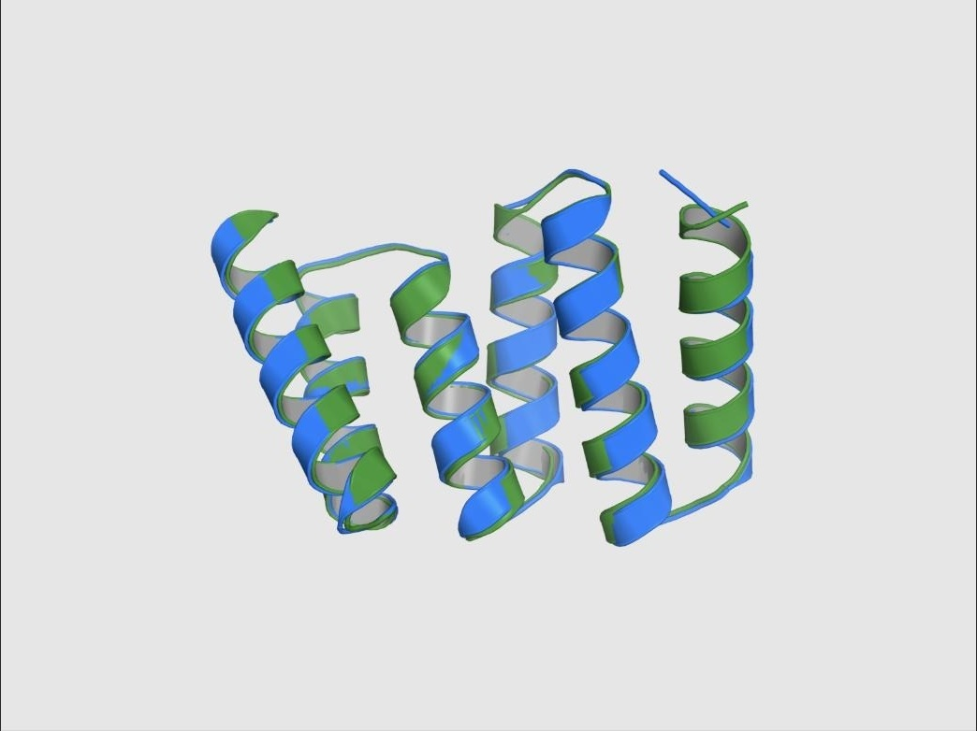
Figure 7
Overlay of the RFdiffusion3-generated binder backbone (green) and the independent AlphaFold 3 standalone binder prediction (blue) for the insulin-receptor rehearsal system, aligning at 0.8255 Å Cα RMSD.
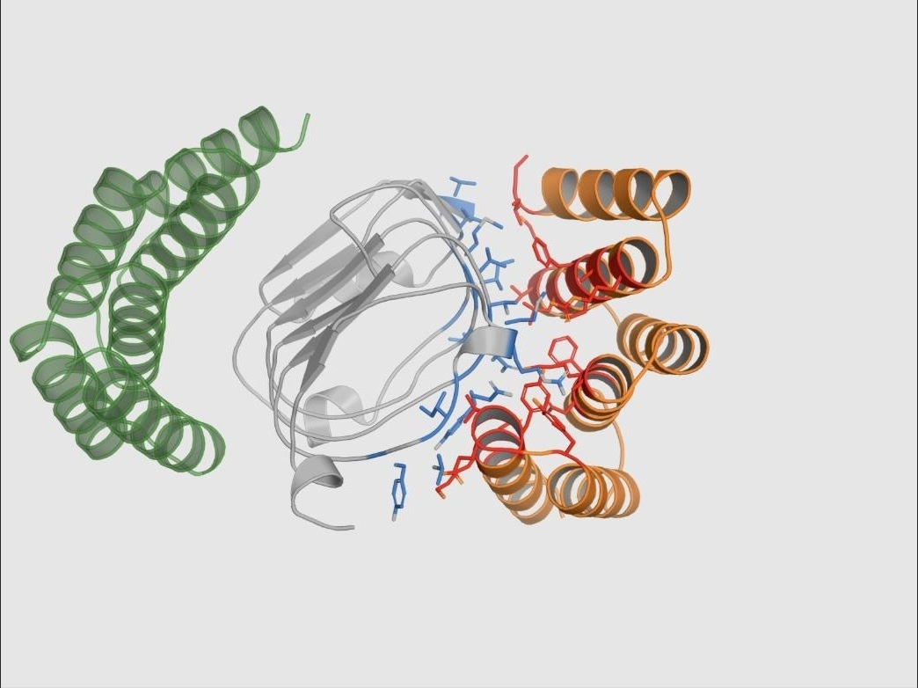
Figure 8
Constrained insulin-receptor complex with the target shown in grey, the independent AlphaFold 3 binder prediction in orange, and the RFdiffusion3-generated reference pose in translucent green, illustrating persistent pose disagreement despite corrected receptor geometry.
Table 2
Known-System (Insulin-Receptor) Rehearsal Metrics
Comparison | RMSD (Å) | Interpretation
Standalone binder (AF3 vs. generated fold) | 0.8255 | Good fold-level agreement
Unconstrained target | 14.0379 | Large receptor drift
Constrained target | 0.3334 | Template conditioning restored target geometry
Constrained binder pose | 47.2323 | Generator complex pose not reproduced
Note. AF3 = AlphaFold 3. RMSD = root-mean-square deviation.
Inputs, Outputs, and Results: NDM-1 Mechanism-Challenge Fixtures
Three NDM-1-specific fixtures tested whether the evaluator would reach the predetermined correct decision on cases designed to be difficult. In the Strategy 1 expected-rejection case (Figure 9), a candidate complex was structurally plausible by several general measures — ipTM 0.69, zero severe clashes, both native zinc ions retained, target RMSD 0.7945 Å — yet its closest qualifying donor atom sat 3.0557 Å from zinc, outside the mechanism's required 2.8 Å shell, with zero supported donors found inside that shell. The evaluator correctly assigned this candidate a mechanism gate failure and a final QA score of 0/100, despite its otherwise favorable general confidence, confirming that the hard mechanism gate — not general model confidence — governs the pass/fail decision. In the Strategy 2 expected-positive case (Figure 10), a candidate achieved ipTM 0.86, target RMSD 0.7546 Å, zero direct zinc-donor contacts, and nine of twelve tracked L3/L10 loop contacts; the evaluator correctly passed this candidate with a mechanism-specific QA score of 92.482/100, while still excluding mismatched second-shell residue labels from credit rather than scoring them uncritically. In the Strategy 3 expected-panel-rejection case (Figures 11 and 12), an isolated zinc-capture state was locally favorable — three histidine donor contacts at 2.113, 2.139, and 2.324 Å, all inside the required 2.8 Å shell — yet the paired product-like state showed no donor within that shell (closest donor 4.679 Å), so the relocation proxy evaluated false; the evaluator correctly rejected the combined mechanism, refusing to let one favorable snapshot stand in for a complete, multi-state sequestration pathway. Together, these three fixtures demonstrate correct rejection of an attractive-but-unsupported candidate, correct acceptance of a mechanism-consistent candidate, and correct rejection of an incomplete multi-state claim (Table 3).
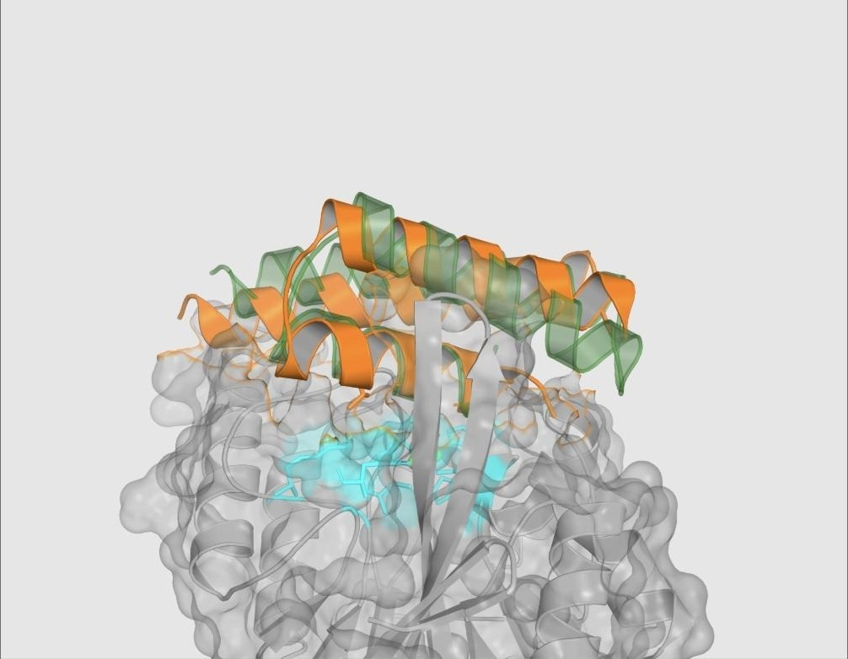
Figure 9
Strategy 1 mechanism-challenge fixture: predicted complex geometry (target surface, generated binder pose, AlphaFold 3 binder pose, and active-site residues) for a candidate correctly rejected by the metal-engagement mechanism gate despite favorable general confidence.
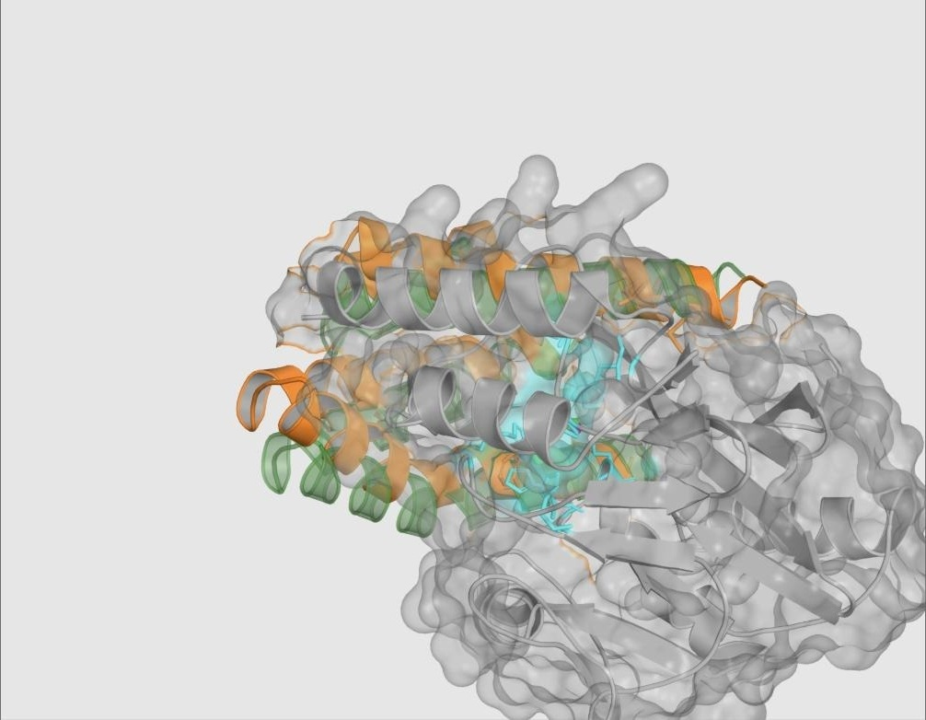
Figure 10
Strategy 2 mechanism-challenge fixture: the zinc-safe predicted binder correctly accepted at the intended L3/L10 loop-adjacent surface, with native-like zinc geometry preserved.
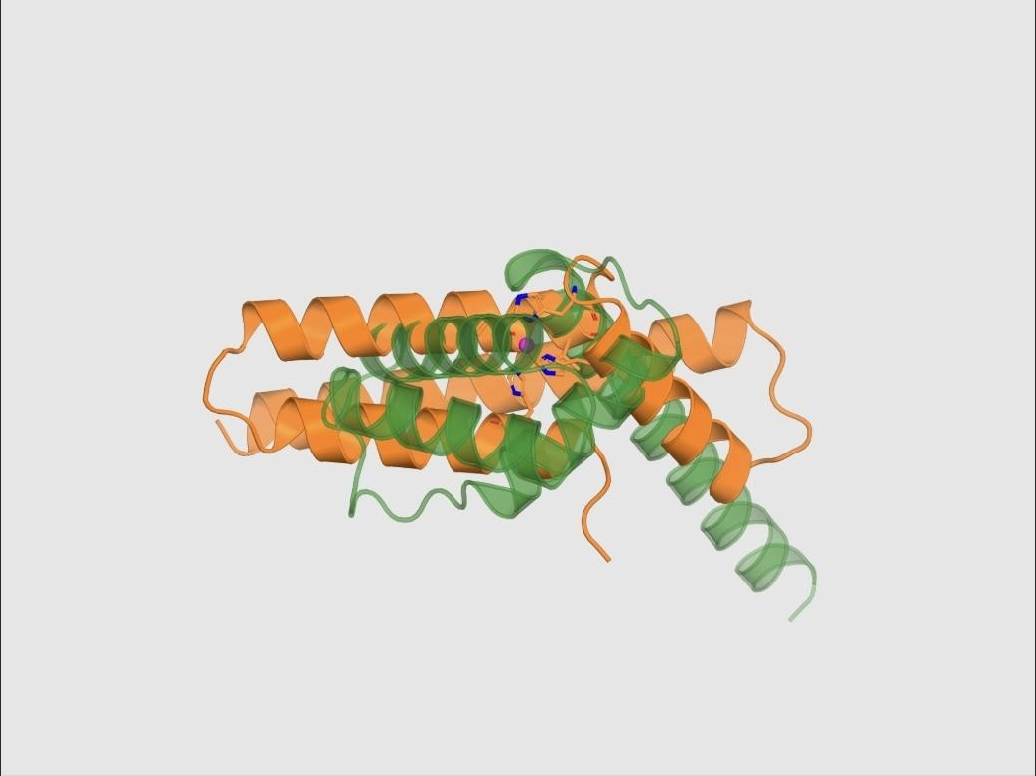
Figure 11
Strategy 3 mechanism-challenge fixture, capture state: overlay of the designed binder and the AlphaFold 3 capture-state prediction around a zinc ion, showing a locally favorable three-donor contact geometry.
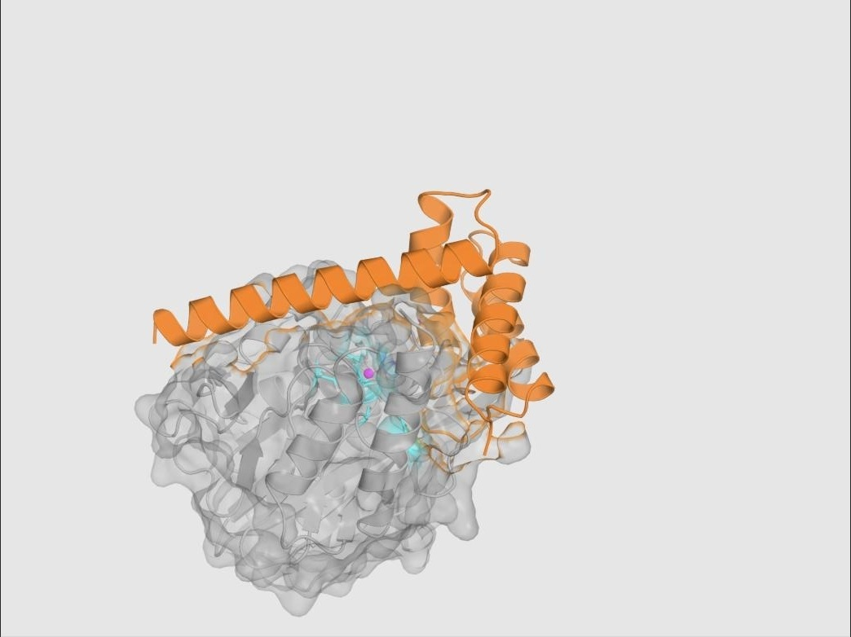
Figure 12
Strategy 3 mechanism-challenge fixture, product-like state: predicted complex showing loss of the required donor proximity, causing the combined relocation mechanism to fail despite the favorable capture-state result in Figure 11.
Table 3
NDM-1 Mechanism-Challenge Fixture Outcomes
Fixture | Key Evidence | Predetermined Expectation | Observed Outcome
Strategy 1 (expected rejection) | ipTM 0.69; donor–Zn 3.0557 Å; 0 supported donors < 2.8 Å | Mechanism gate fails | Failed; score 0/100 (correct)
Strategy 2 (expected positive) | ipTM 0.86; 9/12 L3/L10 contacts; 0 direct donor–Zn contacts | Mechanism gate passes | Passed; score 92.482/100 (correct)
Strategy 3 (expected panel rejection) | Capture donors 2.113–2.324 Å; product-state donor 4.679 Å | Combined mechanism fails | Failed (correct)

Measurement Validation: The qBlock Geometric Envelope
The Strategy 1 active-site-obstruction measurement (qBlock) was validated as a reproducible geometric calculation rather than a subjective visual judgment. A reference substrate-access envelope was built from seven carbapenem-bound NDM-1 structures (Figure 5), aligned into each candidate's AlphaFold 3 frame — in the validation case, across 232 Cα pairs at 0.794 Å RMSD (Figure 13) — and binder overlap with that envelope was measured on a 0.5 Å grid (Figure 14). In the reported validation instance, the reference envelope volume was 701.000 Å³, the binder-occupied volume was 4,792.750 Å³, the blocked envelope volume was 327.625 Å³, and the resulting blocked fraction of 0.4674 mapped, after the campaign's 0–0.30 saturation ramp, to a qBlock value of 1.0000. The explicit interpretive limit recorded alongside this measurement is that qBlock is geometric evidence of substrate-access-region occupancy; it does not measure enzyme inhibition, binding energy, or antibiotic rescue.
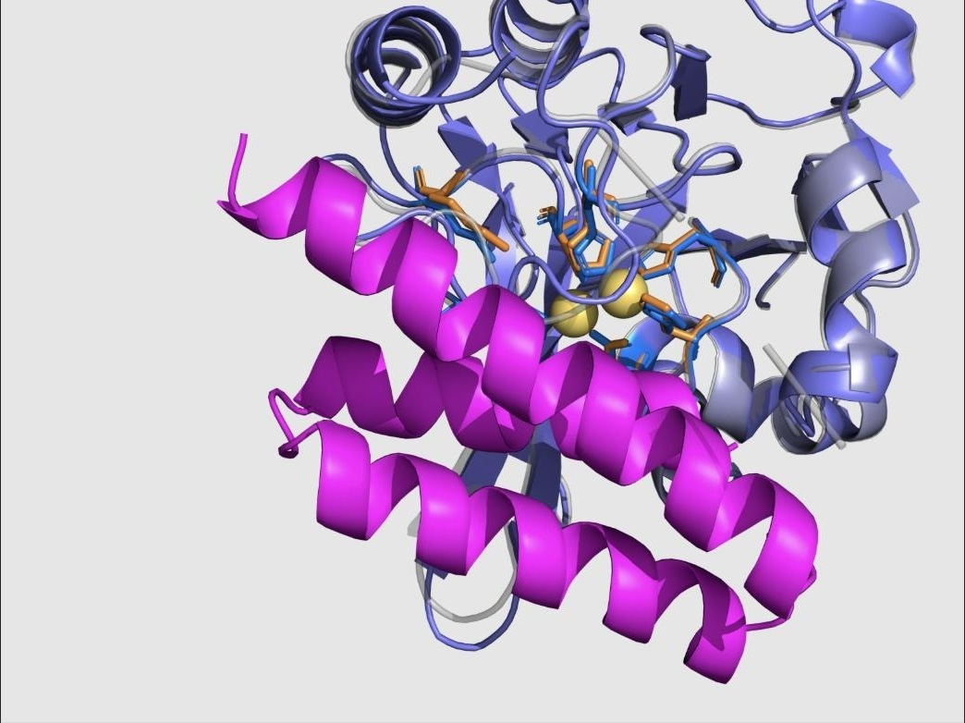
Figure 13
Alignment of the input NDM-1 structure and the AlphaFold 3 target structure into a common frame (232 Cα pairs, 0.794 Å RMSD), with the binder shown in magenta, as the second step of the qBlock measurement procedure.
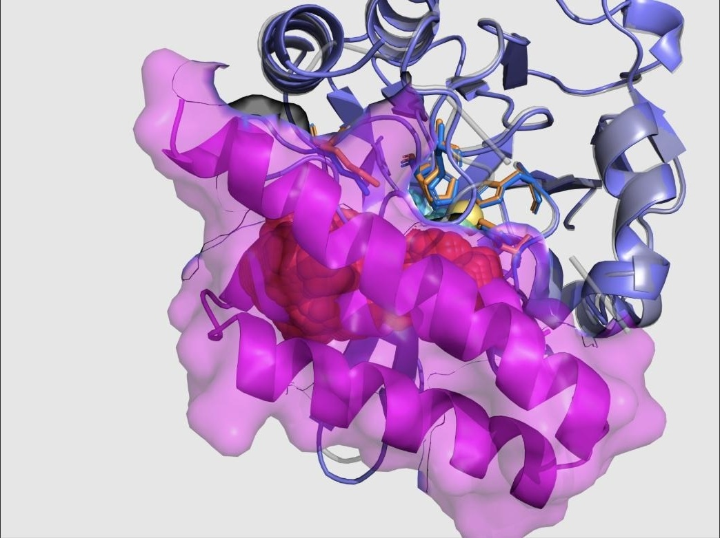
Figure 14
Measured overlap between the binder volume (magenta) and the substrate-access envelope, with the blocked sub-volume highlighted in red, as the third step of the qBlock measurement procedure.
QA Program Outcome
Across the full QA archive, 19 successful remote model-execution reports were preserved (4 RFdiffusion3, 4 LigandMPNN, and 11 AlphaFold 3 executions; these are preserved execution reports rather than a count of unique predicted structures, since a single AlphaFold 3 execution can return multiple ranked samples). Table 4 summarizes the six verification questions the QA program was designed to answer and the evidence supporting each. The QA archive establishes that the remote pipeline executes intended jobs correctly, that target and binder identities are preserved and independently verified, that zinc constraints are measured post-execution rather than assumed from input intent, and that the evaluator both rejects unsupported mechanism claims and accepts supported ones on held fixtures designed for exactly this purpose. It does not, and was never intended to, establish any biological activity claim.
Table 4
Summary of the Evaluator Quality-Assurance Program
Verification Question | Evidence Used | Outcome
Can the remote pipeline execute the intended jobs? | Health/capability checks, dry runs, real submissions, polling, downloaded artifacts, preserved execution reports | Verified on tested paths
Are target and binder identities preserved? | Binder-only extraction, target sequence comparison, chain counts, length checks, residue maps, identity-aware selectors | Verified
Are target and zinc constraints actually honored? | Post-run target RMSD, zinc counts, zinc displacement, coordination geometry, warnings | Measured post-run
Can an attractive model fail for the right reason? | Insulin pose disagreement; Strategy 1 donor failure; Strategy 3 incomplete state panel | Correct rejections observed
Can a mechanism-consistent fixture pass? | Strategy 2 target preservation, zinc avoidance, loop contacts, confidence, identity exclusions | Positive case observed
Has biological activity been validated? | No binding, inhibition, zinc-transfer, cellular, delivery, or toxicity experiment in the QA archive | Not established

Experiment 2: Bounded Arbor Optimization Campaigns
Objective
To determine whether a bounded, evidence-preserving autonomous search agent, operating under the QA-verified evaluator and restricted to editing only a generation-configuration payload, could move each of the three mechanism hypotheses from a gate-failing baseline to a gate-passing computational result, and to preserve a complete, auditable record of the search process, including failures, for later inspection.
Experimental Setup and Configuration
Three independent Arbor sessions were run, one per mechanism strategy, each rooted at a fixed baseline payload and a protected, strategy-specific evaluator. All three sessions fixed RFdiffusion3 generation seed 1000 and AlphaFold 3 model seed 1 on their live development evaluation path, cached results by normalized payload hash, and were restricted to editing solution_payload.json only; the target structure, evaluator implementation, scoring code, baselines, selection rules, and QA materials remained protected throughout. Table 5 reports overall search statistics. Across the three sessions, the exported hypothesis trees contain 54 displayed nodes (three root task contracts plus 51 proposed research nodes), of which 23 leaves returned a successfully scored development evaluation, 12 of which were accepted as merge events that updated the current best payload; three additional attempts (all in Strategy 3) failed at the infrastructure level and were preserved for retry rather than silently discarded. Combined elapsed session time across the three archived runs was 14 hours 39 minutes.
Table 5
Arbor Search Statistics by Strategy
Strategy | Session ID / Duration | Tree Nodes | Scored Evaluations | Accepted Merges | Failed Runs
S1: Metal-engaging | run_20260702_052041 · 5h25m09s | 15 | 9 | 5 | 0
S2: Allosteric | run_20260702_135712 · 6h01m03s | 17 | 8 | 4 | 0
S3: Sequestering | run_20260703_062722 · 3h12m35s | 22 | 6 | 12 (cumulative)* | 3
Note. *Total accepted merge events across all three sessions equal 12; per-session merge counts as displayed in the source archive are 5 (S1), 4 (S2), and 3 (S3). Duration and node counts are taken directly from the preserved Arbor session exports.
Results: Master Score Table
All three strategies moved from a gate-failing baseline objective (below 1.0) to a gate-passing final objective (above 1.0). Table 6 reports the baseline and final Arbor objective, the corresponding raw structural score, and the final sequence length for each strategy. As emphasized throughout this report, the three final objective values are not directly comparable as a cross-strategy ranking, because each strategy applies different mechanism-specific gates and C/D scoring terms; a value above 1.0 indicates only that a given strategy's own gates passed.
Table 6
Master Results Summary Across the Three NDM-1 Minibinder Strategies
Strategy | Intended Mechanism | Baseline Objective | Final Objective | Raw Score /100 | Length (aa)
1. Metal-engaging | Single-donor active-site clamp | 0.814476 | 1.654622 | 96.981 | 58
2. Allosteric | Zinc-safe L10/Asn220 loop clamp | 0.578058 | 1.830660 | 92.296 | 76
3. Sequestering | Relocation-scoring pose; capture unresolved | 0.596382 | 1.863375 | 91.848 | 63
Note. Baseline and Final are Arbor development-search objective values (1 + campaign-adjusted score/100); values above 1.0 indicate that both the common structural gate and the strategy-specific mechanism gate passed.
Strategy 1 (Metal-Engaging): Setup, Outcome, and Analysis
Strategy 1 search explored a design space bounded by a geometry–stability tradeoff: designs could reach the zinc center early in the search, but only an A211-scaffold-supported, approximately 58-residue architecture retained both the core structural gate and the metal-engagement mechanism gate simultaneously. The final accepted design (node 1.1.1.7, payload hash 75a5da272d3f8e86) placed exactly one supported donor atom (Asp28 OD1) at 2.509 Å from zinc, refining an earlier two-donor sibling design (node 1.1.1.6, objective 1.622729) by removing a redundant, unsupported second donor that had triggered an over-chelation penalty (Table 7; Figure 15). The final complex achieved ipTM 0.88 and binder pLDDT 85.73, with an interface term B of 0.95793 across 95 contacts and 1,477 Å² of buried surface area, a mechanism engagement term (CME) of 1.00000, a metal-realism term (DME) of 0.90164, and a substrate-envelope obstruction of 46.34% (qBlock = 1.00000), yielding a raw structural score of 96.981/100 and a final Arbor objective of 1.654622, up from a gate-failing baseline of 0.814476.
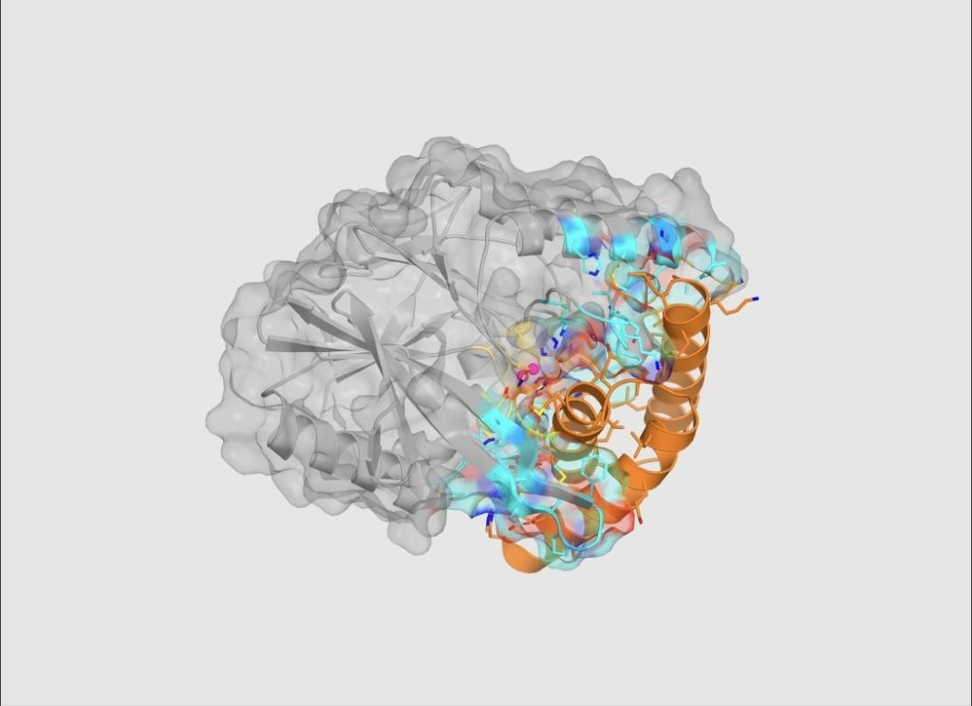
Figure 15
Selected Strategy 1 lead (node 1.1.1.7, payload 75a5da272d3f8e86): PyMOL rendering of the top metal-engaging predicted complex, with NDM-1 in grey, the 58-residue binder in orange occupying the catalytic-groove face, zinc ions in magenta, and interface residues in color.
Table 7
Strategy 1 Rank Comparison Among Related A211-Lineage Candidates
Rank / Node | Arbor Objective | Key Distinction
1 · 1.1.1.7 | 1.654622 | 58 aa, one donor, merged (final lead)
2 · 1.1.1.6 | 1.622729 | 58 aa, two donors, over-chelation penalty
3 · 1.1.1.4 | 1.585964 | 61 aa, one donor, lower length reward
Note. All three ranked candidates derive from the same A211-supported lineage; their structural similarity strengthens the local design lesson but does not constitute independent replication.
The selected Strategy 1 sequence (58 residues) is:
DHARRVALAGEIAEQLLKTGVEPMIAGDGAAHLASRGADPALLAEGIALAKAAMKAAA
An explicit interpretation boundary applies to this result: the zinc-realism term (D) used a native-holo fallback reference because no metal-engaging inhibitor reference ensemble was supplied for this strategy, so the pose does not reproduce a known inhibitor template, and the active-site overlap calculation remains a geometric obstruction proxy rather than a measured energetic or kinetic quantity. A predicted 2.509 Å donor–zinc distance is predicted geometry, not measured coordination chemistry, binding affinity, or catalytic inhibition.
Strategy 2 (Allosteric): Setup, Outcome, and Analysis
Strategy 2 search identified its highest-confidence result through a focused A209/A220 generation contract that produced a broad, loop-adjacent interface while keeping every counted binder donor atom outside the 2.8 Å zinc-contact gate across six independently evaluated AlphaFold 3 models. The final accepted design (node 2.1.3, payload a7e5b1c44be3f2ea) is a 76-residue binder achieving ipTM 0.87 and binder pLDDT 87.37, an interface term B of 0.94887 across 57 contacts and 1,288 Å² of buried surface area, loop contacts of L3 = 5 and L10 = 9 (second shell = 1), and a zinc separation of PdirectZn = 0 with a nearest donor at 5.5009 Å, for a raw structural score of 92.296/100 and a final Arbor objective of 1.830660 — the highest final objective among the three strategies, though again not directly comparable to the other two strategies' objectives (Figure 16). Notably, the search's own retrospective analysis found that the realized gain came predominantly from interface confidence and core structural quality rather than from the originally intended increase in second-shell contact count, since only a single second-shell residue (Asn220) ultimately counted toward the C term — an instance of the search correcting its own causal story about why a candidate scored well.
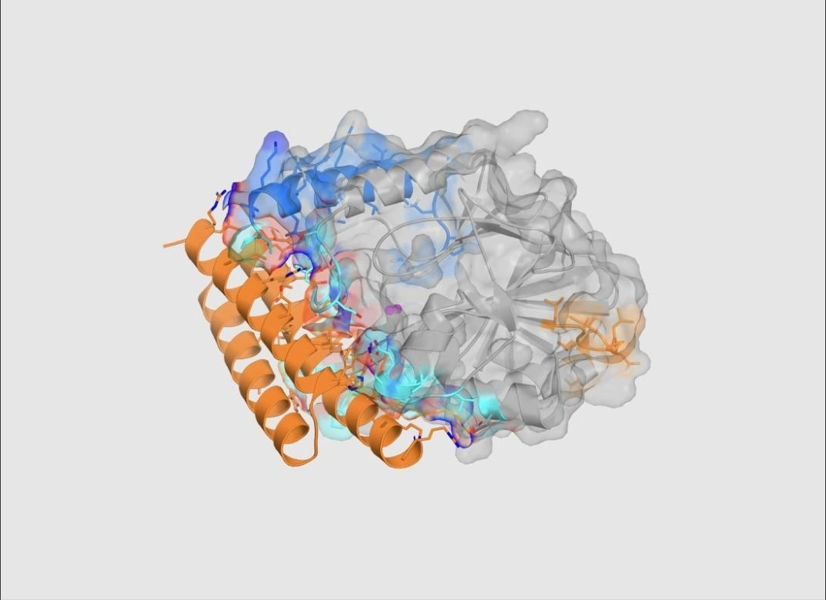
Figure 16
Selected Strategy 2 lead (node 2.1.3, payload a7e5b1c44be3f2ea): PyMOL rendering of the top allosteric predicted complex, showing the 76-residue orange binder forming a broad loop-adjacent interface at L3 and L10 while the magenta zinc center remains spatially separated from binder donor atoms.
A third-ranked Strategy 2 candidate illustrates why scalar score alone is an insufficient selection criterion. Table 8 shows that a compressed clamp variant (node 2.1.4) achieved a higher objective (1.768233) than a diagnostic sibling (node 1.1.1, objective 1.793155) yet was deliberately pruned because its direct-zinc-contact penalty term (PdirectZn) equaled 1.0, indicating unwanted direct donor–zinc coordination inconsistent with the allosteric hypothesis; this pruned candidate is retained in the archive as a useful negative control demonstrating that a protected mechanism penalty, not raw rank, governed advancement.
Table 8
Strategy 2 Rank Comparison, Including a Deliberately Pruned High-Scoring Model
Rank / Node | Arbor Objective | Decision Evidence
1 · 2.1.3 | 1.830660 | A209/A220 clamp; PdirectZn = 0; merged (final lead)
2 · 1.1.1 | 1.793155 | L3 diagnostic; residual ensemble zinc risk
3 · 2.1.4 | 1.768233 | Compressed clamp; PdirectZn = 1.0; pruned

The selected Strategy 2 sequence (76 residues) is:
SREAARQAALAAKAGEYALEKAIEAALEKDCEKAREYIKLAEQYRDQVAALGGTYHAALLAEGIARAEALLERLCK
An explicit interpretation boundary applies here as well: the qBlock active-site-obstruction measurement was unavailable and omitted for this strategy, and detailed identity checking excluded nominal His116, His118, and Asp236 second-shell contact positions because their observed residue identities did not match the intended target labels; a proposed Leu209 contact was similarly not recovered. The evidence therefore supports a zinc-safe predicted binding pose, not a demonstration of dynamic allosteric modulation, which would require experimental methods sensitive to conformational dynamics (for example, NMR or hydrogen–deuterium exchange mass spectrometry) that this computational campaign did not perform.
Strategy 3 (Zinc Sequestration): Setup, Outcome, and Analysis
Strategy 3 search produced a compact 63-residue design (node 1.1.1.3, payload 8eb4eb5751bcef00) that passed its implemented multi-state gate and achieved the highest raw strategy-specific objective of the three campaigns, yet whose capture chemistry remained explicitly incomplete. The selected encounter-state complex achieved ipTM 0.89 and binder pLDDT 80.86, an interface term B of 0.88999 across 98 contacts and 1,769 Å² of buried surface area, mechanism terms CMS = 1.00000 and DMS = 0.72993, relocation and local-apo proxies of qReloc = 1.00000 and qLocalApo = 0.94067, for a raw structural score of 91.848/100 and a final Arbor objective of 1.863375 (Figure 17). However, the capture composite term — qCapture = 0.45·qBcoord + 0.35·qBgeom + 0.20·qPocket — decomposed to qBcoord = 0.60653 (one donor reached Zn2), qBgeom ≈ 6.4 × 10⁻¹² (effectively zero bidentate geometry, against an intended two-donor coordination), and qPocket = 1.00000, yielding a composite qCapture of only 0.47294: positive under the current gate, but chemically incomplete, since only one of two intended zinc-coordinating donors (a cysteine donor at 2.064 Å) was actually recovered in the capture state (Table 9; Figures 18–21).
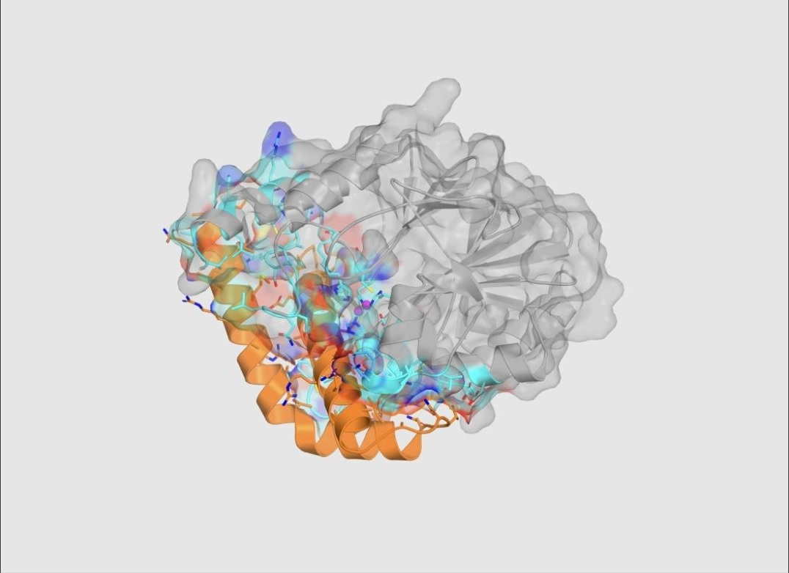
Figure 17
Selected Strategy 3 encounter-state lead (node 1.1.1.3, payload 8eb4eb5751bcef00): PyMOL rendering of the top metal-sequestering encounter prediction, supplying the shared confidence, interface, and active-site terms for the selected result.

Figure 18
Predicted standalone fold of the selected Strategy 3 binder, the first of the four required state-panel predictions.
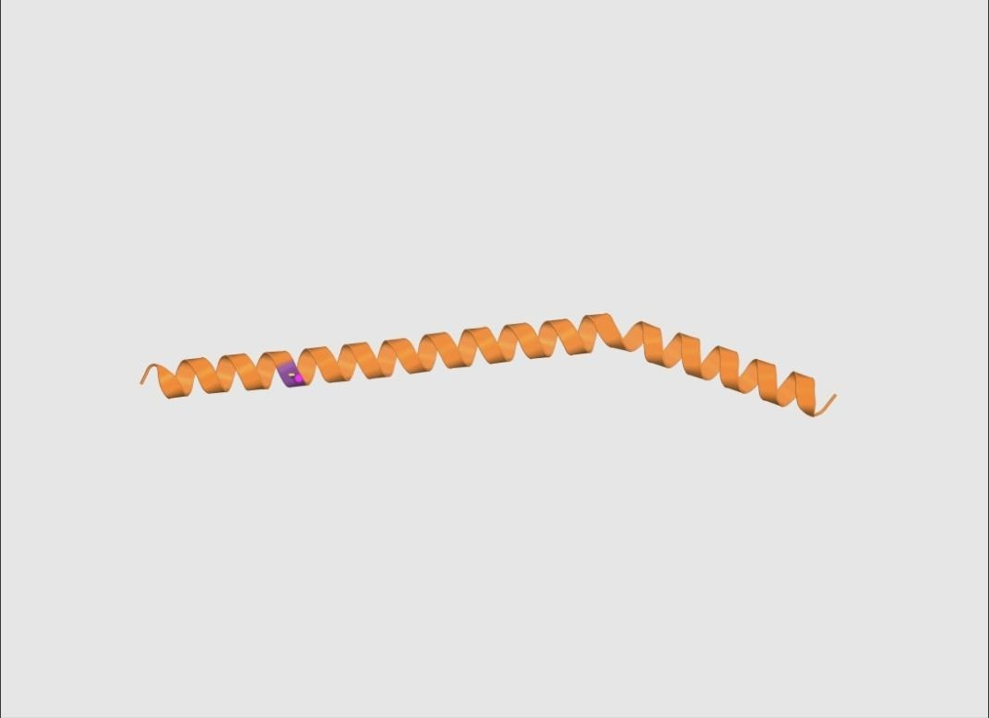
Figure 19
Predicted zinc-capture construct for the selected Strategy 3 binder, showing a single recovered cysteine donor contact (2.064 Å) against an intended two-donor coordination geometry.
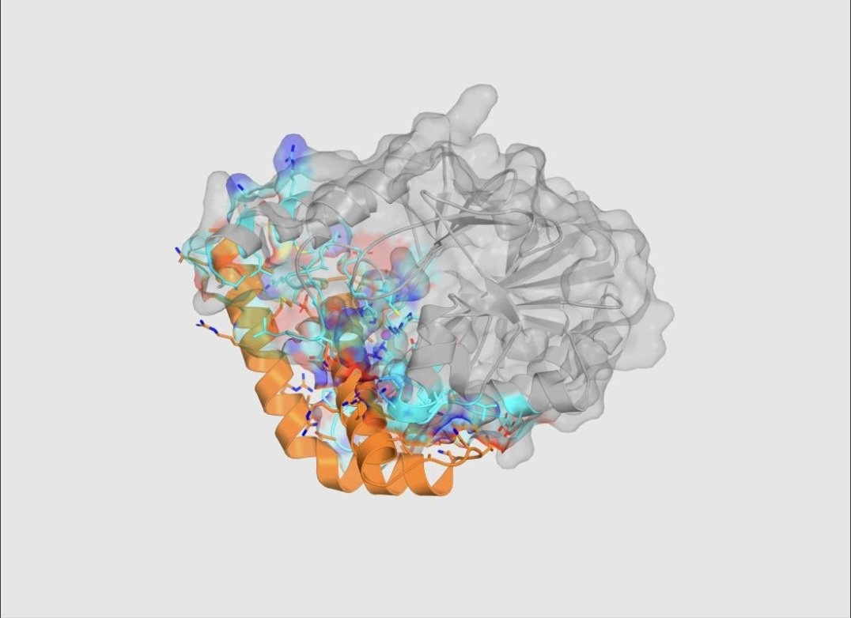
Figure 20
Predicted product-like complex used in the selected Strategy 3 state-panel score, supplying relocation and local-apo-site evidence.
Table 9
Decomposition of the Strategy 3 Capture Composite Term (qCapture)
Sub-term | Value | Interpretation
Donor proximity (qBcoord) | 0.60653 | One donor reached Zn2
Bidentate geometry (qBgeom) | ≈6.4 × 10⁻¹² | Effectively zero; two-donor geometry not achieved
Local pocket (qPocket) | 1.00000 | High-confidence local environment
Composite (qCapture) | 0.47294 | Positive under the current gate, but chemically incomplete
Note. qCapture = 0.45·qBcoord + 0.35·qBgeom + 0.20·qPocket.
Table 10 compares the selected lead to two alternative Strategy 3 candidates and shows that the highest-scoring candidate did not carry the strongest capture evidence: a second-ranked candidate (node 2.1.1.3, objective 1.845187) achieved a substantially higher qCapture of 0.62057 while scoring lower overall, because the winning objective was driven primarily by predicted confidence and interface quality rather than by capture-geometry evidence. This tradeoff is the principal reason Strategy 3 is treated in this report as a mechanism hold requiring redesign rather than as a candidate ready for advancement.
Table 10
Strategy 3 Rank Comparison: The Objective Favored Confidence Over Capture Evidence
Rank / Node | Arbor Objective | Mechanism Evidence
1 · 1.1.1.3 | 1.863375 | qCapture 0.47294; qReloc 1.0; merged (final lead)
2 · 2.1.1.3 | 1.845187 | qCapture 0.62057; qReloc 1.0; not selected
3 · 4.1.1.2 | 1.813776 | A223 flank variant; qReloc 0.3333; not selected

The selected Strategy 3 sequence (63 residues) is:
SEGQETLEAMRAAAVRAEATLPAAEALLRANRTNADASDEAIRRAARSACGHAAIATEIAAAR
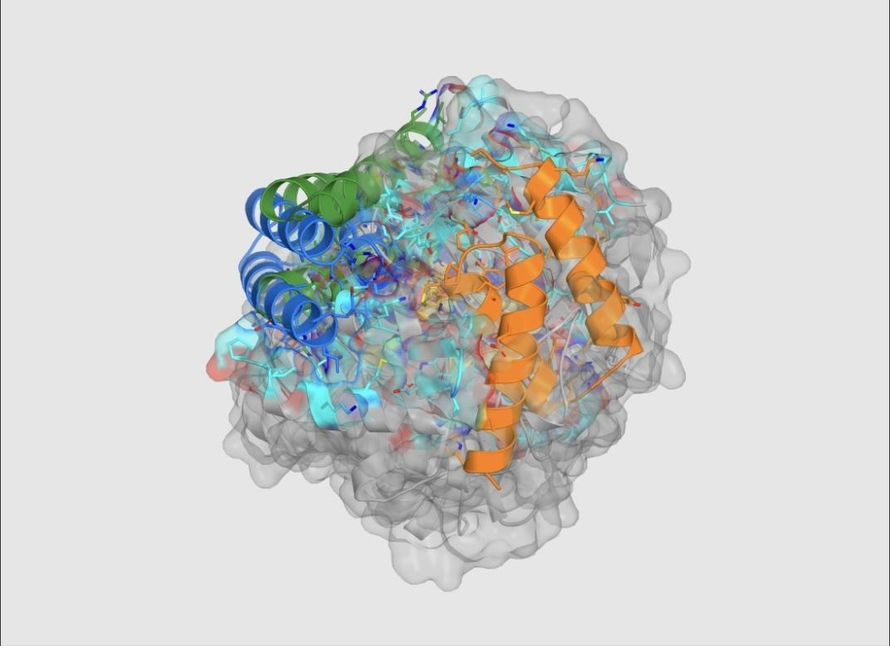
Figure 21
Combined overlay of the three highest-ranked Strategy 1 (metal-engaging) predicted structures (rank 1 orange, rank 2 blue, rank 3 green), rendered in exported AlphaFold 3 coordinate frames without additional structural alignment.
Cross-Strategy Synthesis and Ablation-Style Analysis
Considered jointly, the three campaigns support a general lesson about mechanism-aware search that runs counter to a naive "highest score wins" heuristic: search was productive precisely when the candidate-generation space was narrowed to a specific, falsifiable structural hypothesis, and when the evaluator kept general model confidence analytically separate from mechanism-specific geometric evidence rather than allowing the former to substitute for the latter. In Strategy 1, one supported donor outperformed a redundant two-donor cluster, showing that direct metal proximity is comparatively easy to achieve but difficult to combine with a stable, non-penalized scaffold. In Strategy 2, a geometrically focused A209/A220 payload outperformed a broader hotspot search, and the search's own causal attribution was subsequently corrected once submetric inspection showed the true driver was interface confidence rather than the intended second-shell contact count. In Strategy 3, predicted confidence measurably outran mechanism chemistry: the highest-scoring candidate solved the shared structural gates without solving the bidentate zinc-capture geometry that actually defines the proposed mechanism, which is the clearest evidence in this report for preserving mechanism-specific submetrics rather than relying on a single aggregate score (Table 11).
Table 11
Cross-Strategy Evidence Comparison
Evidence Question | Strategy 1 (Metal-Engaging) | Strategy 2 (Allosteric) | Strategy 3 (Sequestering)
Confident predicted complex? | Yes; ipTM 0.88 | Yes; ipTM 0.87 | Yes; ipTM 0.89
Intended local geometry achieved? | Partly; one zinc donor | Partly; loop clamp, one second-shell contact | Weak; one of two intended capture donors
Primary unresolved risk | Coordination energetics and selectivity | Whether an actual allosteric (dynamic) effect exists | Bidentate capture and relocation mechanism
Disposition | Advance through computational de-risking | Highest-priority computational lead | Mechanism hold; redesign required

Failure Analysis and Lessons Learned
Beyond the three merged leads, the evidence archive deliberately preserves negative and failed results, on the reasoning that a low score can falsify a scientific assumption while an infrastructure error cannot, and that conflating the two would corrupt the search's causal record. Table 12 reports three representative preserved cases. In Strategy 1, node 1.1.1.1 improved donor–zinc distance to 2.295 Å and passed the metal-engagement gate, yet its score (0.755063) fell below the 0.814476 baseline because core structural confidence (Gcore) failed — establishing that solving donor reach without preserving scaffold confidence is not, on net, an improvement. In Strategy 2, node 4.1.1 applied unconstrained sequence resampling under fixed geometry and inadvertently introduced a cysteine zinc donor, driving the direct-zinc-contact penalty to 1.0 and the score down to 1.670814 — establishing that geometry-level zinc safety does not automatically survive unconstrained sequence redesign, and that metal-aware residue constraints are required during sequence design, not only during backbone generation. In Strategy 3, node 2.1.1.1 experienced a live RFdiffusion3 job disappearance during polling (HTTP 404) before any artifact or definitive score was produced; this was correctly preserved as an infrastructure failure requiring retry under stable conditions, explicitly not as evidence against the underlying mechanism hypothesis.
Table 12
Representative Preserved Failures and Their Distilled Lessons
Node | What Happened | What the Search Learned | Status
S1 · 1.1.1.1 | Donor–Zn improved to 2.295 Å and passed the metal gate, but Gcore failed; score 0.755063 vs. 0.814476 baseline | Solving donor reach without preserving scaffold confidence is not an improvement | Done (retained as negative evidence)
S2 · 4.1.1 | Unconstrained sequence resampling introduced a cysteine zinc donor; PdirectZn → 1.0; score fell to 1.670814 | Geometry-level zinc safety does not survive unconstrained sequence resampling | Done (retained as negative evidence)
S3 · 2.1.1.1 | Live RFdiffusion3 job disappeared during polling (HTTP 404) before artifacts or a score were produced | No mechanism conclusion is justified; infrastructure, not chemistry, failed | Needs retry

What the Computational Results Do and Do Not Establish
Summarizing across all experiments, this computational campaign accurately established three mechanism-distinct, AlphaFold-3-predicted structural hypotheses, each with a reproducible generation recipe, a QA-verified mechanism-specific score, and a complete, auditable Arbor search trace including negative results. It did not establish, and does not claim to establish, physical binding to NDM-1, enzymatic inhibition, zinc-transfer energetics, selectivity against related or unrelated zinc-dependent proteins, periplasmic delivery, restoration of antibiotic susceptibility, or any measure of therapeutic efficacy. This boundary is not incidental to the reporting of these results; it is the deliberate product of the evaluator design described in the Method section, and it directly shapes the staged experimental roadmap developed in the Discussion below.
Discussion
Major Findings and Scientific Interpretation
Three findings anchor this report. First, a mechanism-aware, multiplicatively gated evaluator can convert a difficult, metal-dependent, conformationally flexible drug target into a set of independently falsifiable computational sub-problems, and doing so changes which candidates a search process favors: across all three strategies, the highest raw confidence candidate was not automatically the mechanism-strongest candidate, and in Strategy 3 the two properties were directly opposed, with the highest-objective candidate carrying weaker capture evidence than a lower-ranked alternative. Second, bounding an autonomous search agent's editable surface to a single generation-configuration artifact, while protecting the target, evaluator, and QA fixtures as a versioned contract, is sufficient to let that agent conduct a genuinely productive 14-hour, 54-node, three-strategy search — the bounded agent is not a diminished agent, it is an accountable one, and all three mechanism hypotheses moved from a gate-failing to a gate-passing state under this constraint. Third, and most broadly, the project's own methodological history is itself evidence for this architecture: the earlier, more broadly autonomous workflow failed specifically because it lacked exactly the protections — separated generation and evaluation, mechanism-specific hard gates, and pre-search QA of the evaluator itself — that the final implemented system supplies, and that failure, documented and corrected within this same project, is treated here as a primary methodological result in its own right, not merely as background.
Comparison With Prior Work
The three inhibition hypotheses tested here connect directly to, but go beyond, prior experimental precedent. Direct metal engagement follows the logic of captopril binding and of computationally designed peptide macrocycle inhibitors that occupy the NDM-1 cleft (King et al., 2012; Mulligan et al., 2021); the present Strategy 1 result extends this logic from a macrocyclic peptide scaffold to a considerably larger, generatively designed 58-residue protein fold, a modality shift whose consequences for coordination geometry, selectivity, and synthetic accessibility remain untested. Zinc sequestration follows the logic of aspergillomarasmine A, a small natural product that restores meropenem susceptibility by capturing dissociated zinc (King et al., 2014; Sychantha et al., 2021); the present Strategy 3 result is explicitly described in this report as a further, as-yet-unvalidated extrapolation from small-molecule to protein-mediated capture, and the quantitative capture-composite decomposition (Table 9) shows precisely why that extrapolation remains incomplete — a single, not bidentate, zinc-coordinating donor was recovered. Allosteric loop control is the most mechanistically unsettled of the three routes even in the existing literature, with a 2019 peer-reviewed report and a 2026 preprint offering competing mechanistic accounts of thanatin activity (Ma et al., 2019; Rivière et al., 2026); the present Strategy 2 result, by design, tests only the zinc-preserving account, and its own resulting evidence — a stable, zinc-safe, loop-adjacent interface with limited second-shell engagement — is consistent with, but does not on its own confirm, that account over the alternative direct-displacement mechanism. Methodologically, this project's use of a hypothesis-tree-refinement search agent operating under a protected evaluator directly instantiates the general Arbor framework (Jin et al., 2026); the present contribution relative to that framework is not architectural but is the construction and QA validation of the target-specific scientific content — the mechanism hypotheses, hard gates, and fixtures — required to make the general architecture trustworthy for this particular, unusually demanding target.
Strengths
The principal strength of this work is methodological accountability: every reported score is traceable to a specific evaluator version, a specific node in a preserved hypothesis tree, and a specific set of downloaded model artifacts, and every quality-assurance claim about the evaluator is itself backed by a documented fixture with a predetermined expected outcome rather than by post hoc assertion. A second strength is the explicit, disciplined separation between candidate generation and candidate evaluation: RFdiffusion3 and LigandMPNN never supply the confidence or geometric evidence used to score their own output, which is instead obtained from an independent AlphaFold 3 prediction, directly addressing the well-documented risk of a generative model implicitly grading itself favorably. A third strength is the preservation of negative and failed results as first-class evidence rather than as discarded noise; the three representative failures analyzed above, and the three infrastructure failures preserved for Strategy 3, materially sharpen the interpretation of the three accepted leads by showing what almost worked and why it did not. A fourth strength is the project's consistent linguistic discipline in reporting computational results, repeatedly and explicitly distinguishing a passing development-objective score from any claim about affinity, efficacy, or probability of success, a discipline this report has deliberately preserved throughout.
Novelty
This section states precisely what is new in this work relative to standard practice in de novo binder design, separates methodological novelty from empirical findings, and is deliberately scoped: novelty claims here mean new relative to standard single-score, single-hypothesis binder-scoring practice and the project's own starting proposal, not unprecedented in any field. Each claim below is checkable against the Method and Experiment sections above and, where numeric, against the preserved Arbor search archive summarized in Tables 7, 8, and 10.
Novelty at a Glance
N1 (methodological, strong). Mechanism-partitioned optimization: the three experimentally motivated NDM-1 inhibition mechanisms — metal engagement, allosteric loop control, and zinc sequestration — are optimized as three separate, falsifiable objectives with independent gates, rather than reduced to one confidence-weighted composite score with mechanism attached only as a post hoc label.
N2 (methodological, strong). A four-state AlphaFold 3 evaluation panel for the zinc-sequestration hypothesis (binder fold, enzyme encounter, zinc capture, and product-like states), combined by a weighted geometric mean so that no single favorable state can compensate for a failing one, with zinc placement deliberately left unbiased so the panel tests metal transfer rather than assuming it.
N3 (methodological, moderate-to-strong). A reference-conditioned zinc-realism term that scores predicted metal geometry against a mechanism-appropriate structural reference ensemble and penalizes donor coordination beyond what that reference supports, directly encoding the medicinal-chemistry observation that potent NDM-1 inhibition does not require strong free-zinc chelation.
N4 (methodological, moderate). A gate-multiplicative scoring architecture in which any hard structural or mechanism failure zeroes the score outright, built specifically to resist reward hacking by an autonomous optimizer against a live structural-confidence signal.
N5 (systems/integration, moderate — the coupling is the novelty). An autonomous, gate-constrained AI agent (Arbor, a GPT-5.5 coordinator–executor hypothesis-tree search agent) is permitted to edit only a bounded candidate-generation payload while the evaluator, target structure, and scoring rules remain locked and unavailable to it, coupling agentic search to a pipeline it cannot itself redefine.
N6 (empirical, strong — falsifiable and discovered autonomously). Design rules the search surfaced without human guidance: a single supported zinc donor outscores two in the metal-engaging strategy; a two-residue allosteric hotspot set (A209/A220) outperforms an eleven-residue diffuse set; a zinc-safe allosteric clamp with zero direct zinc contact is achievable while preserving native di-zinc geometry; and, in the sequestration strategy, structural confidence and zinc relocation are partly antagonistic objectives.
Mechanism-Partitioned Optimization as the Core Conceptual Novelty
Standard de novo binder-scoring practice, including the minimum-viable scoring scheme in this project's own starting proposal, collapses a candidate to a single composite of confidence, interface, and developability terms, with an inhibition mechanism attached afterward as a descriptive tag rather than used as a scoring criterion. Because a single zinc-centric rubric systematically penalizes a valid allosteric binder for preserving the very di-zinc center it is supposed to leave intact, this project instead treated the three inhibition hypotheses as three separate optimization problems, each scored for the chemistry appropriate to its own mechanism: direct zinc engagement scored for zinc contact, the allosteric route scored for zinc safety, and sequestration scored for zinc transfer. This partition, not any single formula within it, is the paper's central conceptual move — the difference between scoring a binder and labeling its mechanism, and optimizing a binder to be a specific mechanism. Empirically, the three Arbor searches converged on genuinely different hotspot geometries and different zinc relationships (Tables 7, 8, and 10), a divergence a single averaged rubric would have obscured.
A Four-State Evaluation Panel and Gate-Constrained Agent Search
Two further methodological contributions support the mechanism-partitioned design. First, because metal sequestration is a transfer process rather than a static pose, no single holo complex can represent it; the Strategy 3 evaluator instead scores a four-state AlphaFold 3 panel — binder fold, enzyme encounter, zinc capture, and a product-like state showing native-site loss — and requires evidence from all four states before a sequestration claim is credited, with zinc placement withheld from the structure predictor so the panel measures transfer rather than assuming it. To our knowledge, standard de novo binder scorers built on ipTM/pLDDT filtering and single-complex structural validation have no equivalent. Second, the resulting mechanism-specific objectives are combined multiplicatively with hard structural and mechanism gates and handed, as a single scalar, to an autonomous AI agent search: Arbor, a GPT-5.5 coordinator–executor hypothesis-tree agent, is free to explore and edit only the candidate-generation payload, while the evaluator code, the target structure, and the scoring rules are locked and outside its reach. This addresses a failure mode encountered directly during the project, in which an earlier, less constrained agentic workflow treated successful pipeline execution as equivalent to biological validity. Across three bounded Arbor sessions and 54 recorded hypothesis-tree nodes, the locked, gated objective was not defeated by a confidence-only shortcut (Tables 7, 8, and 10) — an empirical robustness result for the gating architecture, not merely a design intention.
Autonomously Discovered, Falsifiable Design Rules
The Arbor searches also produced design rules that were not specified in advance and that are independently checkable against the archived score tables. In the metal-engaging strategy, a single supported zinc donor (node 1.1.1.7, Arbor objective 1.654622) outscored an otherwise similar two-donor design penalized for exceeding the reference-supported coordination count (node 1.1.1.6, Arbor objective 1.622729; Table 7). In the allosteric strategy, collapsing an eleven-residue diffuse L3/L10 hotspot set to the two-residue A209/A220 pair raised AlphaFold 3 ipTM to 0.87 while holding the direct-zinc-contact penalty at zero (Table 8), yielding a zinc-safe clamp that preserves native di-zinc realism, a computational instance of the thanatin-like allosteric mechanism discussed in the Introduction. In the sequestration strategy, the node the objective favored achieved higher structural confidence at the cost of the zinc-relocation term relative to an alternative candidate (Table 10), a cautionary finding about the geometry–confidence relationship that the fixed evaluator was specifically built to surface rather than obscure. Each rule is tied to a specific node and metric in the preserved Arbor archive and can therefore be checked or refuted by re-running the harness, which is what distinguishes it from an anecdotal observation.
What Is Not Novel
The generative and structural-prediction tools used in this project, RFdiffusion3, LigandMPNN, AlphaFold 3, and BindCraft-style confidence filtering, are used as published, without modification. The underlying biology, the identity of the NDM-1 active-site residues and zinc ligands, the L3/L10 loop definitions, the three candidate inhibition mechanisms, and the captopril, thanatin, and aspergillomarasmine A precedents motivating them, is drawn from the literature reviewed above, not discovered by this project. The general idea of layered structural filters combined with normalized sub-scores and Pareto-style tracking of non-dominated candidates was already present in the project's own starting proposal; the contribution here is the mechanism-partitioned, gate-multiplicative, reference-conditioned realization of that idea and the autonomous agent search built on top of it. Finally, and most importantly, no wet-laboratory work of any kind was performed: every claim of novelty in this section is computational and methodological, and none of it demonstrates that any candidate binds NDM-1, inhibits the enzyme, resensitizes a resistant strain, or crosses the outer membrane, as discussed further under Limitations below.
Statement of Contribution
Taken together, this project reframes de novo NDM-1 binder design from maximizing a single confidence-weighted composite score to autonomously optimizing, under a gate-constrained AI agent search, toward one of three mechanistically defined and reward-hacking-resistant objectives, including a four-state AlphaFold 3 panel that, to our knowledge, has no precedent for the metal-transfer hypothesis it tests, and shows that the resulting search recovers biologically sensible, mechanism-distinct designs together with a fully traceable evidence archive.
Limitations
Several limitations bound the strength of the conclusions that can be drawn from this campaign. First, and most fundamentally, no biological or biochemical experiment was performed at any stage: every reported metric is a computational prediction or a geometric measurement derived from a computational prediction, and none constitutes direct evidence of binding, catalysis, or cellular activity. Second, the evaluator's numerical thresholds — the 2.8 Å donor-distance cutoff, the ipTM and pLDDT minimums, the seven-contact requirement, and the specific term weightings in the raw-score formula — are campaign heuristics chosen for internally consistent triage rather than values calibrated against experimentally confirmed positives, negatives, and decoys; the project's own scoring documentation states this limitation explicitly. Third, all three Arbor searches relied on a single structural oracle (AlphaFold 3) evaluated at a single fixed model seed for the live development objective, with no independent structure predictor, no replicate-seed distribution, and no held-out evaluator used during search — the Arbor framework's own held-out (Etest) admission check, present in its general formulation, was not available in these particular runs, so the reported scores are more precisely development-search scores than validated benchmark scores. Fourth, mechanism-specific evidence gaps differ meaningfully by strategy and are not uniform: the Strategy 1 zinc-realism term relied on a native-holo fallback reference in the absence of a metal-engaging inhibitor reference ensemble; the Strategy 2 qBlock measurement was unavailable for the selected lead; and the Strategy 3 capture composite is, by the evaluator's own arithmetic, dominated by a near-zero bidentate-geometry term, meaning its passing status reflects a currently permissive gate threshold rather than resolved capture chemistry. Fifth, delivery was out of scope for the entire campaign: no experiment, computational or otherwise, addressed whether a 58–76-residue folded protein could cross the Gram-negative outer membrane to reach native, membrane-anchored NDM-1 in an intact bacterial cell, a problem this report treats as a separate and dominant translational risk rather than as solved or even substantially addressed by the present results.
Clinical and Drug-Discovery Implications
If, and only if, subsequent independent computational replication and biochemical testing confirm one or more of these mechanisms, the intended clinical role described in this project is not standalone antibacterial killing but use as an NDM-1 inhibitor co-administered with a susceptible β-lactam — within this project's scope, primarily a carbapenem — to restore antibiotic activity in NDM-positive Gram-negative infections, following the general adjuvant logic already established for metallo-β-lactamase inhibition by aspergillomarasmine A (King et al., 2014). This report explicitly cautions against a common but unsupported inferential shortcut in this space: the existence of approved serine-β-lactamase-inhibitor combination products (for example, those containing avibactam or vaborbactam) establishes only that the combination regulatory and clinical format is viable, not that any candidate targeting a structurally and mechanistically distinct metallo-β-lactamase will show similar activity; NDM-1 coverage must be demonstrated independently for any candidate arising from this or related work. More broadly for computational drug discovery, this project offers a transferable methodological template — mechanism-specific hard gates, pre-search evaluator QA with predetermined fixtures, and bounded rather than fully open autonomous search — that is presented in this report's own proposed extension as directly portable to small-molecule, catalyst, and materials design problems, provided that a comparably rigorous, target-specific evaluator and QA program is constructed for each new problem rather than reusing a generic score across unrelated targets.
Future Research
The project's own next-step roadmap, synthesized here, stages future work by the strength of evidence supporting it rather than by convenience, and it treats a negative or null result at any stage as scientifically informative rather than as project failure. The first work package is independent computational challenge: freezing all current versions of the target, sequences, payloads, evaluator, and decision criteria; repeating predictions across multiple random seeds and reporting pose, confidence, zinc-state, and rank as distributions rather than single best-of-seed images; introducing at least one independent complex-prediction or docking method as an orthogonal check; and testing donor-null, contact-breaking, and composition-matched negative-control variants for each strategy, with an explicit go rule that a hypothesis must reproduce across seeds, survive an independent method, and outperform matched negative controls before advancing. The second work package is a compact experimental candidate panel of roughly 8–12 constructs per production round spanning each strategy's lead, close structural siblings, mechanism-breaking variants, and matched assay controls (including NDM-1 alone, a literature chelator or inhibitor control, and non-NDM zinc-enzyme counter-screens), rather than the single top-ranked sequence in isolation. The third phase of work is staged physical evidence generation, proceeding in order from production and quality control of soluble material — beginning with the well-characterized soluble C26A NDM-1 comparator so that membrane-delivery questions are not prematurely mixed into the first biochemical question — through direct quantitative binding measurement (for example, by surface plasmon resonance, biolayer interferometry, or isothermal titration calorimetry), structural confirmation (preferentially by X-ray crystallography where feasible, or by a combination of NMR, hydrogen–deuterium exchange mass spectrometry, mutational interface mapping, and crosslinking mass spectrometry), enzymatic inhibition assays with explicit tests of zinc dependence and reversibility, and finally mechanism- and selectivity-resolving experiments against related (VIM, IMP) and unrelated human zinc metalloproteins, with each strategy assigned its own falsification-oriented mechanism test — donor-null chelation controls for Strategy 1, loop-contact-disruption mapping for Strategy 2, and explicit zinc-transfer kinetics and stoichiometry measurements for Strategy 3. The fourth work package directly addresses the dominant unsolved translational risk, periplasmic delivery, through five parallel routes ranging from near-term use of the minibinder purely as a purified-protein research tool, through a periplasmic-expression positive-access control, exploratory hijacking of active siderophore- or colicin-like uptake systems, combination testing with a non-bactericidal outer-membrane permeabilizer, to the strategically favored long-term route of miniaturizing the validated interaction — beginning with Strategy 1's comparatively localized donor-and-groove pharmacophore — into a constrained peptide, macrocycle, or peptidomimetic small molecule whose uptake properties can be engineered directly, following the general computational-chemistry extension ("Agent-Chem") this project has proposed but explicitly not yet implemented or QA-qualified. Across all of these future stages, this report recommends predeclaring, before data collection, the specific evidence required to advance, hold, or stop each strategy, so that the same evidentiary discipline established for the computational phase of this project is carried forward into its experimental phase.
Conclusion
This report has synthesized a three-month applied research program that began with a conventional small-molecule proposal against LRRK2, developed a generative-protein diagnostic concept for alpha-synuclein, and culminated in an implemented, mechanism-aware computational campaign against NDM-1, a zinc-dependent metallo-β-lactamase responsible for clinically significant carbapenem resistance. The central contribution is a reusable proposal-to-evidence research platform in which a scientific proposal is converted into an explicit, hard-gated scoring design; that scoring design is itself quality-assured against known-valid, known-invalid, and boundary fixtures before use; the resulting tested Evaluator Pack is sealed as a versioned scientific contract; and an autonomous hypothesis-tree search agent, Arbor, is then permitted to search only within the narrow, editable surface that contract defines, while every branch, success, and failure is preserved as traceable evidence. Applied to NDM-1 under three independently falsifiable inhibition hypotheses, this platform produced three reproducible, mechanism-distinct computational leads — a 58-residue metal-engaging clamp, a 76-residue zinc-safe allosteric clamp, and a 63-residue sequestration candidate with unresolved bidentate capture chemistry — each supported by a complete, auditable generation recipe, structural score, and search history.
These results constitute a computational milestone, not a therapeutic one. They establish that generative protein design, when bound to an independently verified, mechanism-specific evaluator, can propose structurally plausible, scientifically interpretable candidates against a genuinely difficult drug target, and that an autonomous search agent can meaningfully accelerate exploration of that candidate space without being permitted to redefine what counts as success along the way. They do not establish physical binding, enzymatic inhibition, antibiotic resensitization, cellular activity, or periplasmic delivery, none of which fell within the scope of this computational campaign. The scientific and translational value of this project, accordingly, lies as much in the discipline of its evidentiary boundary — in what it declines to claim — as in the three candidates it proposes. The staged experimental roadmap developed in this report, moving from independent computational replication through biochemical and biophysical validation, delivery-route assessment, and peptidomimetic miniaturization, is offered as the appropriate next authority for converting this computational prioritization into tested biological knowledge, and, should that knowledge accumulate favorably, toward an eventual β-lactam adjuvant candidate capable of restoring antibiotic activity against NDM-positive Gram-negative pathogens.

References
Author lists below are reproduced exactly as documented by the ClearVoice AI research portal's own citation lists, which give the first author followed by "et al." without disclosing a complete author string for most entries. No author names have been added, inferred, or invented beyond what the source portal itself supplied.
Abramson, J., et al. (2024). Accurate structure prediction of biomolecular interactions with AlphaFold 3. Nature.
Anstine, D. M., et al. (2025). AIMNet2: A neural network potential to meet your neutral, charged, organic, and elemental-organic needs. Chemical Science.
Batatia, I., et al. (2022). MACE: Higher order equivariant message passing neural networks for fast and accurate force fields. Advances in Neural Information Processing Systems (NeurIPS).
Chai Discovery Team, et al. (2024). Chai-1: Decoding the molecular interactions of life. bioRxiv. (Preprint)
Corbett, D., et al. (2017). Potentiation of antibiotic activity by a novel cationic peptide: Potency and spectrum of activity of SPR741. Antimicrobial Agents and Chemotherapy.
Corso, G., et al. (2023). DiffDock: Diffusion steps, twists, and turns for molecular docking. International Conference on Learning Representations (ICLR).
Feng, H., et al. (2017). The mechanism of NDM-1-catalyzed carbapenem hydrolysis is distinct from that of penicillin or cephalosporin hydrolysis. Nature Communications.
Feng, W., et al. (2024). Generation of 3D molecules in pockets via a language model. Nature Machine Intelligence.
Genheden, S., et al. (2020). AiZynthFinder: A fast, robust and flexible open-source software for retrosynthetic planning. Journal of Cheminformatics.
González, L. J., et al. (2016). Membrane anchoring stabilizes and favors secretion of New Delhi metallo-β-lactamase. Nature Chemical Biology.
Housden, N. G., et al. (2010). Directed epitope delivery across the Escherichia coli outer membrane through the porin OmpF. Proceedings of the National Academy of Sciences (PNAS).
Jin, J., Hu, Y., Qiu, K., et al. (2026). Toward generalist autonomous research via hypothesis-tree refinement. arXiv:2606.11926.
Kang, J. S., et al. (2018). Virtual screening and experimental testing of B1 metallo-β-lactamase inhibitors. Journal of Chemical Information and Modeling.
King, A. M., et al. (2014). Aspergillomarasmine A overcomes metallo-β-lactamase antibiotic resistance. Nature.
King, D. T., et al. (2012). New Delhi metallo-β-lactamase: Structural insights into β-lactam recognition and inhibition. Journal of the American Chemical Society.
Kumarasamy, K. K., et al. (2010). Emergence of a new antibiotic resistance mechanism in India, Pakistan, and the UK. The Lancet Infectious Diseases.
Ma, B., et al. (2019). The antimicrobial peptide thanatin disrupts the bacterial outer membrane and inactivates the NDM-1 metallo-β-lactamase. Nature Communications.
Merchant, A., et al. (2023). Scaling deep learning for materials discovery. Nature.
Mulligan, V. K., et al. (2021). Computationally designed peptide macrocycle inhibitors of New Delhi metallo-β-lactamase 1. Proceedings of the National Academy of Sciences (PNAS).
Passaro, S., et al. (2025). Boltz-2: Towards accurate and efficient binding affinity prediction. bioRxiv. (Preprint)
Peptide2Mol: A diffusion model for generating small molecules as peptide mimics for targeted protein binding. (2025). arXiv. (Preprint; author not specified by source)
Peukert, C., et al. (2023). Trojan horse siderophore conjugates induce Pseudomonas aeruginosa suicide and qualify the TonB protein as a novel antibiotic target. Journal of Medicinal Chemistry.
Poirel, L., et al. (2011). Genetic features of blaNDM-1-positive Enterobacteriaceae. Antimicrobial Agents and Chemotherapy.
Potron, A., Poirel, L., & Nordmann, P. (2011). Plasmid-mediated transfer of the bla(NDM-1) gene in Gram-negative rods. FEMS Microbiology Letters.
Prunotto, A., et al. (2020). Molecular bases of the membrane association mechanism potentiating antibiotic resistance by New Delhi metallo-β-lactamase 1. ACS Infectious Diseases.
Rivière, G., et al. (2026). Allosteric inhibition of NDM-1 by thanatin preserves the di-zinc center while restricting dynamics. bioRxiv. (Preprint; not peer reviewed)
RUC-NLPIR. (n.d.). Arbor [Computer software]. GitHub. https://github.com/RUC-NLPIR/Arbor
Spratt, B. G. (1977). Properties of the penicillin-binding proteins of Escherichia coli K12. European Journal of Biochemistry.
Stewart, A. C., et al. (2017). Clinical variants of New Delhi metallo-β-lactamase are evolving to overcome zinc scarcity. ACS Infectious Diseases.
Sychantha, D., et al. (2021). Aspergillomarasmine A inhibits metallo-β-lactamases by selectively sequestering Zn2+. Journal of Biological Chemistry.
Tu, Z., et al. (2025). ASKCOS: An open source software suite for synthesis planning. arXiv. (Preprint)
Yong, D., et al. (2009). Characterization of a new metallo-β-lactamase gene, blaNDM-1, and a novel erythromycin esterase gene carried on a unique genetic structure in Klebsiella pneumoniae. Antimicrobial Agents and Chemotherapy.
Zeni, C., et al. (2025). A generative model for inorganic materials design. Nature.
Zhang, H., & Hao, Q. (2011). Crystal structure of NDM-1 reveals a common β-lactam hydrolysis mechanism. FASEB Journal.
Zhou, G., et al. (2023). Uni-Mol: A universal 3D molecular representation learning framework. International Conference on Learning Representations (ICLR).
Zhu, J., et al. (2023). DiffBindFR: An SE(3) equivariant network for flexible protein-ligand docking. arXiv. (Preprint)

Appendix
This appendix reports supplementary figures, configuration and hyperparameter tables, verbatim Arbor task-contract (prompt) examples, dataset and archive statistics, and additional supporting tables referenced from the main text.
A1. Supplementary Target-Biology Figures
Figures 22 and 23 provide the explanatory target-biology context that motivated the project's three inhibition hypotheses; both are explicitly conceptual overviews rather than atomic structural models, per the source portal's own captioning.
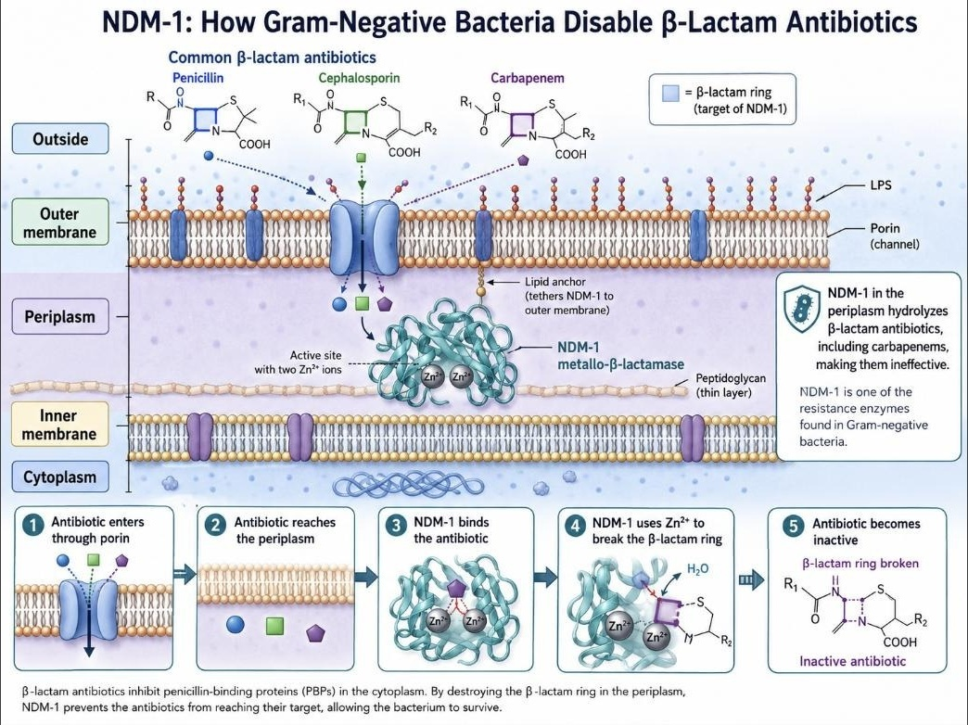
Figure 22
Conceptual overview of NDM-1 catalytic mechanism: outer-membrane porin entry of a β-lactam antibiotic, periplasmic NDM-1 anchored to the inner leaflet of the outer membrane via a lipid anchor, active-site engagement by the two catalytic zinc ions, and hydrolytic opening of the β-lactam ring.
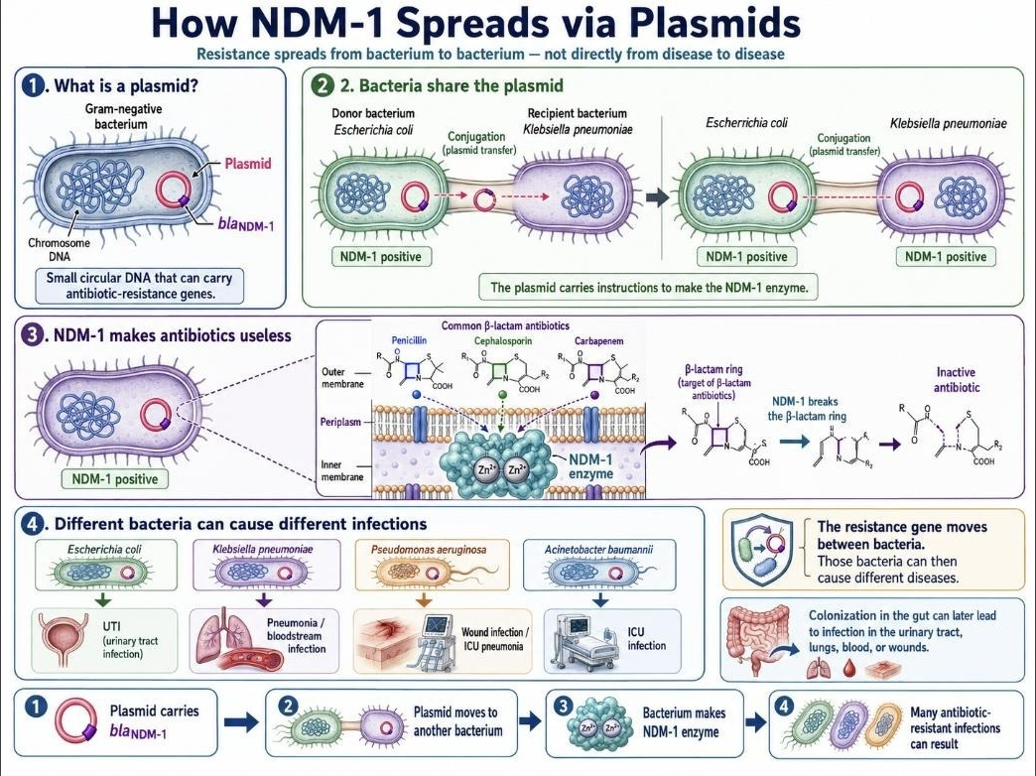
Figure 23
Conceptual overview of plasmid-mediated dissemination of blaNDM-1 by conjugative transfer between Gram-negative bacteria, illustrating one major dissemination route rather than a universal history for every NDM-positive isolate.
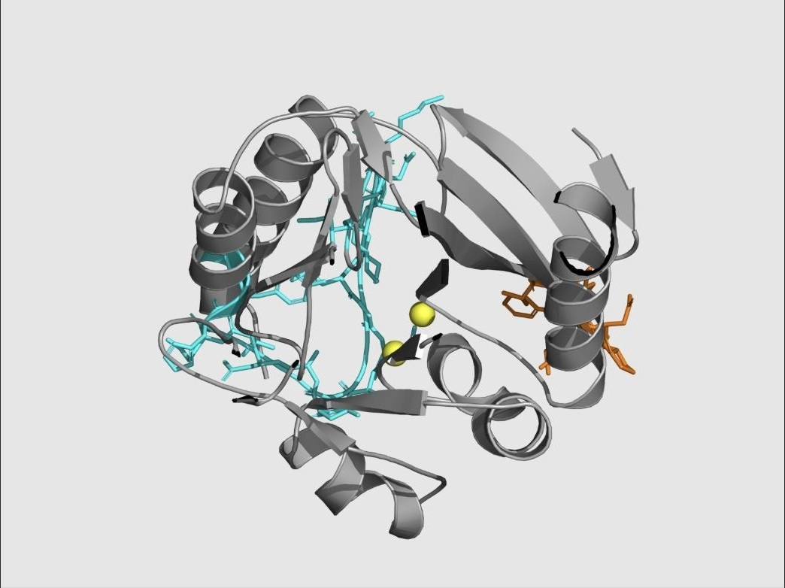
Figure 24
NDM-1 target structure (grey) with the L3 loop (orange), L10 loop (cyan), and the two catalytic zinc ions (yellow spheres) mapped and verified against author residue numbering as part of target-preparation quality assurance.
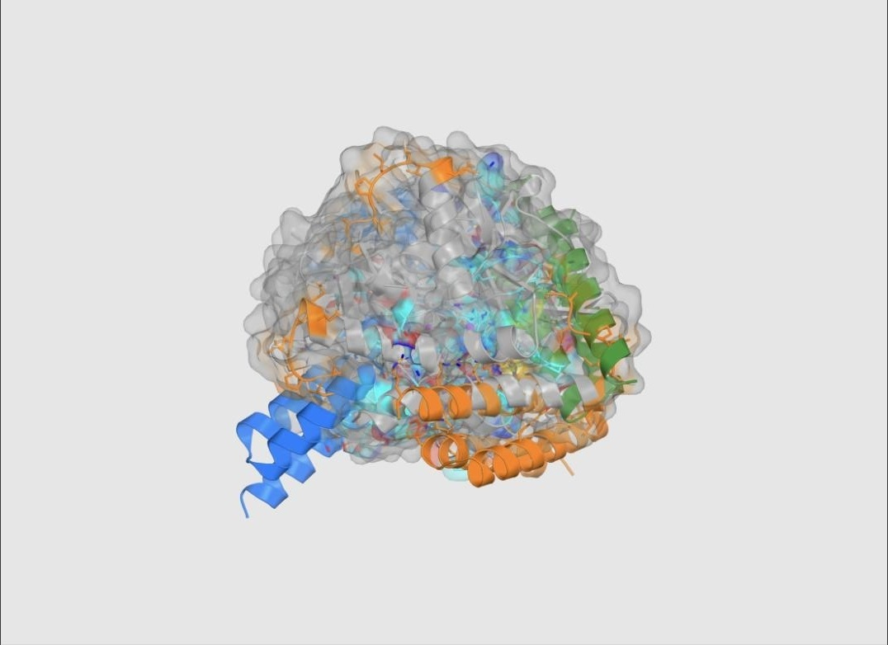
Figure 25
Combined overlay of the three highest-ranked Strategy 2 (allosteric) predicted structures (rank 1 orange, rank 2 blue, rank 3 green), illustrating that the shortlist spans more than one loop-adjacent pose family.
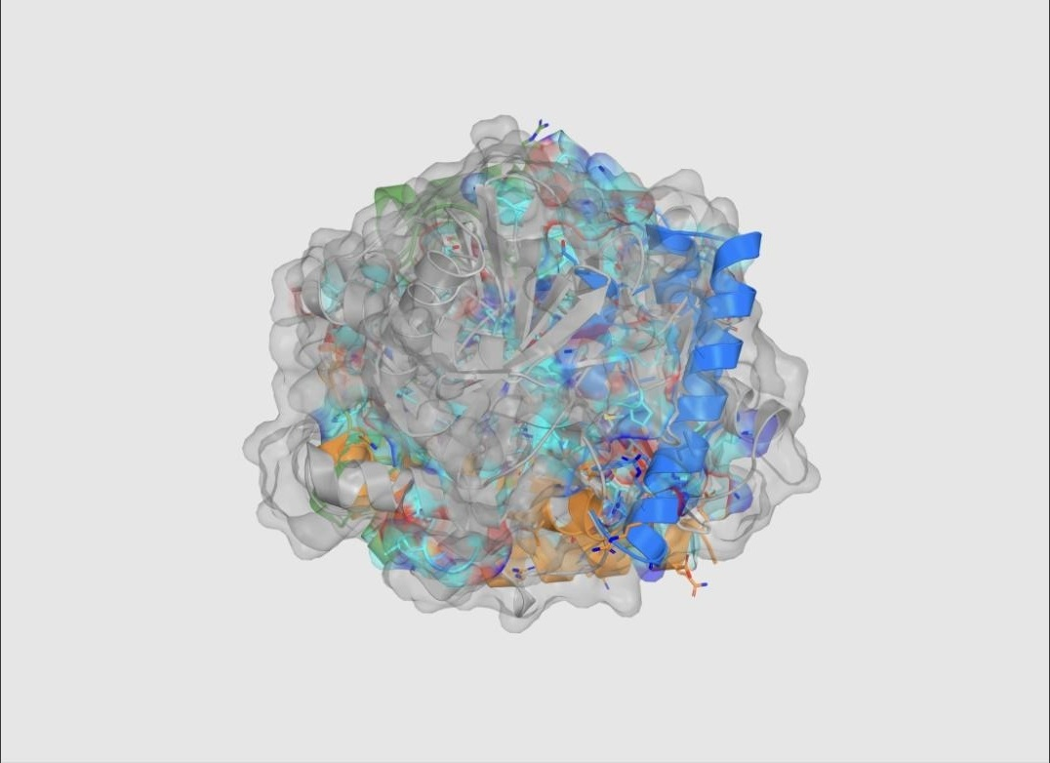
Figure 26
Combined overlay of the three highest-ranked Strategy 3 (sequestering) encounter-state structures (rank 1 orange, rank 2 blue, rank 3 green).
A2. Hyperparameters and Search Configuration
Table A1
Fixed Hyperparameters and Search Budgets Across the Three Arbor Sessions
Parameter | Value
RFdiffusion3 generation seed (live dev path, all sessions) | 1000
AlphaFold 3 model seed (live dev path, all sessions) | 1
Caching policy | Cache by normalized solution_payload.json hash; identical payload reuses existing live evidence
Editable scope (all sessions) | solution_payload.json only
Protected artifacts (all sessions) | baseline_payload.json, eval.sh, eval.py, finalist_replicates.py, payload_builder.py, design_selectors.py, objective.py, research_config.yaml, research_docs/**, qa_tests/**, scorer/eval machinery
Held-out (Etest) evaluation used during search | No (all sessions; live development objective only)
Strategy 1 search-scope preference | Effect-leaning
Strategy 2 execution mode | Sequential (one candidate experiment at a time)
Strategy 3 cycle budget | Exactly 9 Arbor cycles
Strategy 3 maximum intended search depth | 3
Strategy 3 search-scope preference | Mixed (scientifically grounded, score-prioritized)
Agent runtime (coordinator and executor roles, all sessions) | gpt-5.5 via OpenAI OAuth
Scientific/GPU compute layer | Modal on-demand serverless GPU services
Note. Values are taken directly from the Arbor task-contract text and session metadata preserved in the source portal's session exports for each strategy.
A3. Verbatim Arbor Task Contracts (Prompt Examples)
The following three blocks reproduce, verbatim, the task-contract text supplied to each strategy's Arbor coordinator, as preserved in the corresponding session export. These are included to satisfy full methodological transparency and reproducibility; the bracketed material in Strategy 1's contract reflects the exact wording of the source export.
Strategy 1 (Metal-Engaging) Task Contract
“Maximize the live Strategy-1 NDM-1 metal-engaging minibinder score printed by bash eval.sh / python eval.py dev, higher is better. Baseline unknown — measure during INIT using the real live eval command; do not use replay/mock scores as the baseline, though an existing valid live cache for the exact payload hash may be used by the harness. Push the live dev score as high as possible within the research_config.yaml budget; use an effect-leaning scope, while grounding hypotheses in the read-only context from research_docs/proposal.txt and research_docs/scoring_design.txt around Strategy 1 / metal-engaging geometry, zinc realism, qblock alignment, interface quality, and carbapenem-relevant scoring. Edit only solution_payload.json; never edit or game baseline_payload.json, eval.sh, eval.py, finalist_replicates.py, payload_builder.py, design_selectors.py, objective.py, README.md, research_config.yaml, research_docs/, qa_tests/, scorer/eval machinery, input structures, zinc policy, AF3 bonded pairs, chain roles, or protected data. There is no held-out test score for Arbor iteration; optimize dev only, do not use bash eval.sh test or finalist replicate seeds during the search loop, and for rerunning an already-seen payload hash rely on the existing live cache behavior — do not set NDM1_FORCE_LIVE=1 or otherwise force expensive Modal API reruns unless explicitly approved by the user.”
Strategy 2 (Allosteric) Task Contract
“Maximize the live Strategy 2 allosteric/conformational score printed by bash eval.sh dev, higher is better; a live Modal baseline has been measured at 0.578058 (mode: live, payload hash fc805b0e92075d91). Push the score as high as possible within a 9-cycle budget, using an effect-leaning search while respecting the Strategy 2 mechanism: improve L3, L10, L3+L10, second-shell/contact persistence, interface quality, and native-like zinc realism, and avoid direct binder-Zn donor coordination. Before proposing hypotheses, inspect research_docs/proposal.txt, research_docs/scoring_design.txt, and strategy_2_target_prep/ as read-only context for how the Strategy 2 target/PDBs and scoring intent were created. Edit only solution_payload.json; do not modify baseline_payload.json, eval.sh, eval.py, finalist_replicates.py, payload_builder.py, design_selectors.py, objective.py, README.md, research_config.yaml, research_docs/, qa_tests/, input structures, scorer logic, Modal/eval harness, or protected data. There is no separate held-out test score for this benchmark: iterate on live dev only, do not use bash eval.sh test or finalist_replicates.py during search, and run candidate experiments sequentially one by one rather than in parallel; structure exploration to include nodes/hypotheses for L3, L10, and combined L3+L10 engagement.”
Strategy 3 (Zinc Sequestration) Task Contract
“Maximize the live Strategy 3 metal-sequestering objective score printed by bash eval.sh dev, higher is better; current cached live dev baseline is 0.596382 for payload hash c619c3238c5bcf3c. Push the score as high as possible within exactly 9 Arbor cycles, with max-depth intent 3, for the NDM-1 Strategy 3 experiment. Use a mixed scope preference: favor scientifically meaningful Strategy 3 hypotheses grounded in research_docs/proposal.txt and research_docs/scoring_design.txt, but prioritize changes that improve the real live dev score. Hard constraints: inspect those research docs before proposing hypotheses; edit only solution_payload.json; never edit baseline_payload.json, eval.sh, eval.py, finalist_replicates.py, payload_builder.py, design_selectors.py, objective.py, README.md, research_config.yaml, research_docs/, qa_tests/, input structures, data, scorer code, or eval harness; keep target_zinc=Zn2, capture_intended_donor_count=2, AF3 zinc placement policy with no zinc bondedAtomPairs, chain roles, and scorer fixed; optimize active-site encounter, binder-Zn capture geometry, product-like relocation/local apo-site formation, interface quality, and target-core preservation; do not use finalist replicate validation or any reserved seeds for iteration.”
A4. Example Arbor Node Record (Full Schema)
Table A2 reproduces one complete Strategy 1 node record from the preserved session export, illustrating the full node schema — address, parent, hypothesis, observable, result, insight, and code reference — used throughout the search.
Table A2
Example Merged Arbor Node (Strategy 1, Node 1.1.1.7)
Field | Content
Node address | 1.1.1.7 (score 1.654622; status: merged)
Parent | 1.1.1 · Canonical Zn-ligand hotspot clamp
Hypothesis | At the working 55–60-residue A211-supported scaffold, biasing away from unsupported over-chelation may keep one useful donor while restoring zinc realism.
Observable | Beat 1.622729, or improve DME/raw score at approximately 58 residues while preserving Gcore and GME.
Result | Length remained 58; Gcore and GME remained 1; donor count moved 2 → 1; qChelate moved 0.5 → 1.0; live development score reached 1.654622.
Insight | A very small sampler adjustment improved single-donor zinc realism; stronger conservative changes overcorrected.
Code reference | coordinator/n1-1-1-7-mechanism-single-donor-zinc-real-4b3a5cf9

A5. Dataset and Archive Statistics
Table A3
Target Structure and Archive Statistics
Statistic | Value
NDM-1 target chain length | 232 residues
Catalytic zinc ions modeled | 2 (Zn1: His120, His122, His189; Zn2: Asp124, Cys208, His250)
L3 loop range / sequence | A65–A73 / LDMPGFGAV
L10 loop range / sequence | A210–A230 / IKDSKAKSLGNLGDADTEHYA
qBlock reference structures (carbapenem-bound NDM-1) | 7
QA-preserved successful execution reports | 19 (4 RFdiffusion3, 4 LigandMPNN, 11 AlphaFold 3)
Displayed Arbor hypothesis-tree nodes (3 strategies) | 54 (3 root contracts + 51 proposed research nodes)
Scored Arbor leaf evaluations | 23
Accepted Arbor merge events | 12
Preserved Arbor infrastructure failures | 3 (all Strategy 3)
Combined Arbor session elapsed time | 14 h 39 min
Final lead sequence lengths | 58 aa (S1), 76 aa (S2), 63 aa (S3)
Approximate final lead molecular masses | ~6.4 kDa (S1), ~8.4 kDa (S2), ~6.9 kDa (S3)
Top-ranked AF3 result bundles retained for comparison | 9 (3 per strategy)
Knowledge Library project video walkthroughs | 16 (6 final report + 10 chronological diary)

A6. Additional Supporting Table: Interpretive Boundary by Strategy
Table A4
What Each Final Lead's Score Does and Does Not Support
Strategy | Supported Interpretation | Not Supported by This Result
1. Metal-engaging | A predicted 58-residue complex placing one supported zinc donor at 2.509 Å under a passed structural and mechanism gate | Measured coordination chemistry, binding affinity, catalytic inhibition, or metal selectivity
2. Allosteric | A predicted 76-residue, zinc-safe, loop-adjacent complex with strong interface confidence and no direct binder–zinc contact | Demonstrated conformational/dynamic allostery, which requires methods such as NMR or HDX-MS not used here
3. Sequestering | A predicted 63-residue encounter complex passing an incomplete four-state gate with high confidence | Resolved bidentate zinc-capture geometry, zinc-transfer chemistry, or NDM-1 core-preservation during transfer

A7. Note on Scope of Portal Content Reviewed
This manuscript synthesizes all ten primary report pages of the ClearVoice AI research portal (Report/Home, Journey, Platform, NDM-1, Scoring, QA Tests, Arbor, Results, Next Steps, and Extending the Platform), the Knowledge Library page, and the six linked interactive Arbor session-review and tree-replay archives for Strategies 1–3. The two earlier project directions — a mutation-resilient LRRK2 inhibitor proposal and an Agent-Syn alpha-synuclein diagnostic-probe proposal — are reported in the Introduction and discussed as proposal-development and system-design contributions; consistent with the source portal's own evidence classification, neither is reported as a completed discovery campaign, and no experimental or computational results are attributed to either beyond what the portal itself documents. The proposed "Agent-Chem" computational-chemistry extension of the platform, described in the Extending the Platform page, is reported in this manuscript strictly as a forward-looking architectural proposal that had not been integrated, QA-qualified, or executed as part of the reported NDM-1 campaign at the time of this synthesis. Background videos, courses, and tool documentation catalogued in the Knowledge Library without complete bibliographic attribution (author name, verifiable title, and venue) were reviewed but are not cited as formal references in this manuscript, consistent with the instruction not to fabricate citation details; they are acknowledged here as part of the project's documented learning record.

